Campus Management Committee
Meeting Minutes
5/20/21

Attendees: Jennifer Carr, Erik Kinzler, James Kinzler, Ken Thompson

Notes on updates to the Campus:

- The Meeting Room ceiling panels and lights replacement is complete. Thanks to Bill Dixon and George Koenig and crew for the work and to all those who donated funds for capital improvement. Take a look at the dramatic transformation.
- Roof leaks remain over Bouton Hall as have been found during replacement of ceiling tiles and lights. Search is in progress for the sources.
- Great job in progress by Bill Dixon, George Koenig and crew in changing out the ceiling panels and lights in Bouton Hall. Thanks to all those who donated funds for capital improvement.
- A roof leak remains in the Hall outside Bouton Hall entrance.
- Changeout of lights in the CE building halls is in progress with 2 new light installed downstairs near Nasa 1. If you get a chance, take a look at this work and again, thank you Bill Dixon and others.
- Breezeway flashing and facia is complete so you can now enter the office without getting rained on.
- Bees that had made a home upstairs in the CE building above the butterfly garden were removed with the guidance of Ed Boyer. The room was cleaned up with the help of Bill Dixon and Joe Schwarz.
- The leak in the Narthex near the doors to the Sanctuary is still active with minor water on the floor during recent rains. There were no leaks near the pulpit so perhaps the last repair by the roofing contractor has resolved the problem.
- Freeze repairs still need to be completed for the hot and cold water lines into the Bouton Hall kitchen.
- Membrane roof repair over the north end of the CE building were completed and no leaks occurred during the recent rain.
- CE building room cleanout is in progress with input from various committees on the materials stored for later use or not. Thanks to Kathy Dixon for leading this effort and her team for their support.
- The men’s urinal in the restroom near the office has been repaired and is back in service.
- Light bulbs were changed out in the Fellowship Hall and some lights redirected to give more balanced lighting. Thanks to Mike Gragg and Bill Dixon for leading this effort and for the work of their crew.

Notes on COVID Protocol:

CMC proposes an update to the COVID protocol to allow use of the CE building for Sunday School classes as long as other protocols like masking are followed. See attached update that was supported by CMC for review by Session next week.

Family Ministries Committee discussed the COVID protocol to perhaps make suggested updates on family centric items. See the attached Protocol references from the CDC and Mayo Clinic that note that children should remain socially distanced. There was no obvious answer on how to keep young children socially distanced.

James

Attachment

Updated Statement of WPC Criteria for COVID and Plans for Reopening Facilities and In Person Worship for support by the Session by the Campus Management Committee, 5/20/21

The Campus Management Committee, Worship Committee, Session and Staff have been working since COVID started on plans and considerations for returning to “in person” worship and other campus uses. We understand that a majority of our older members are now vaccinated but that others are not. We will continue following guidelines to keep people safe. We all look forward to being together in the Sanctuary. See our plans below.
- Continue to monitor the Harris County criteria for whether COVID is “under control” in the Greater Houston Area. Controlling the rate of COVID-19 transmission is key to reopening. Per the County, the “new case trend” criteria indicator is “Met” with the 14 day trend of new cases decreasing by 11 cases per day.
- AV Technology is coming to allow for in person worship and also for recording worship for youtube. It is expected that the tech needed will be ready in about 2 weeks. This is key so that both folks that want to participate in person and those who want to participate via youtube can both do so.
- Continue to follow Texas and CDC guidance for masking, social distancing…
- Worship will provide Ushers to check congregants relative to COVID and to seat them and escort out for exiting.
- Families with children must have the children sit with the family at all times. Kids play area will be temporarily be out of service.
- Bathrooms are open but the water fountain is not on.
- For congregational singing, it is key that masks stay on.
- There will be formal separation of Choral Scholars and AV Scholars from the Congregation.
- The Office is closed and not available for Congregation use.
- The CE building is not open on Sunday for Sunday School. [Propose Session support deletion of this item.]
- Session has supported the use of the WPC Campus for WPC groups to meet and for community groups to meet as long as the protocols for COVID checks, logging, and use of a WPC liaison are followed.
For more details from Harris County, see the Criteria and Status below.

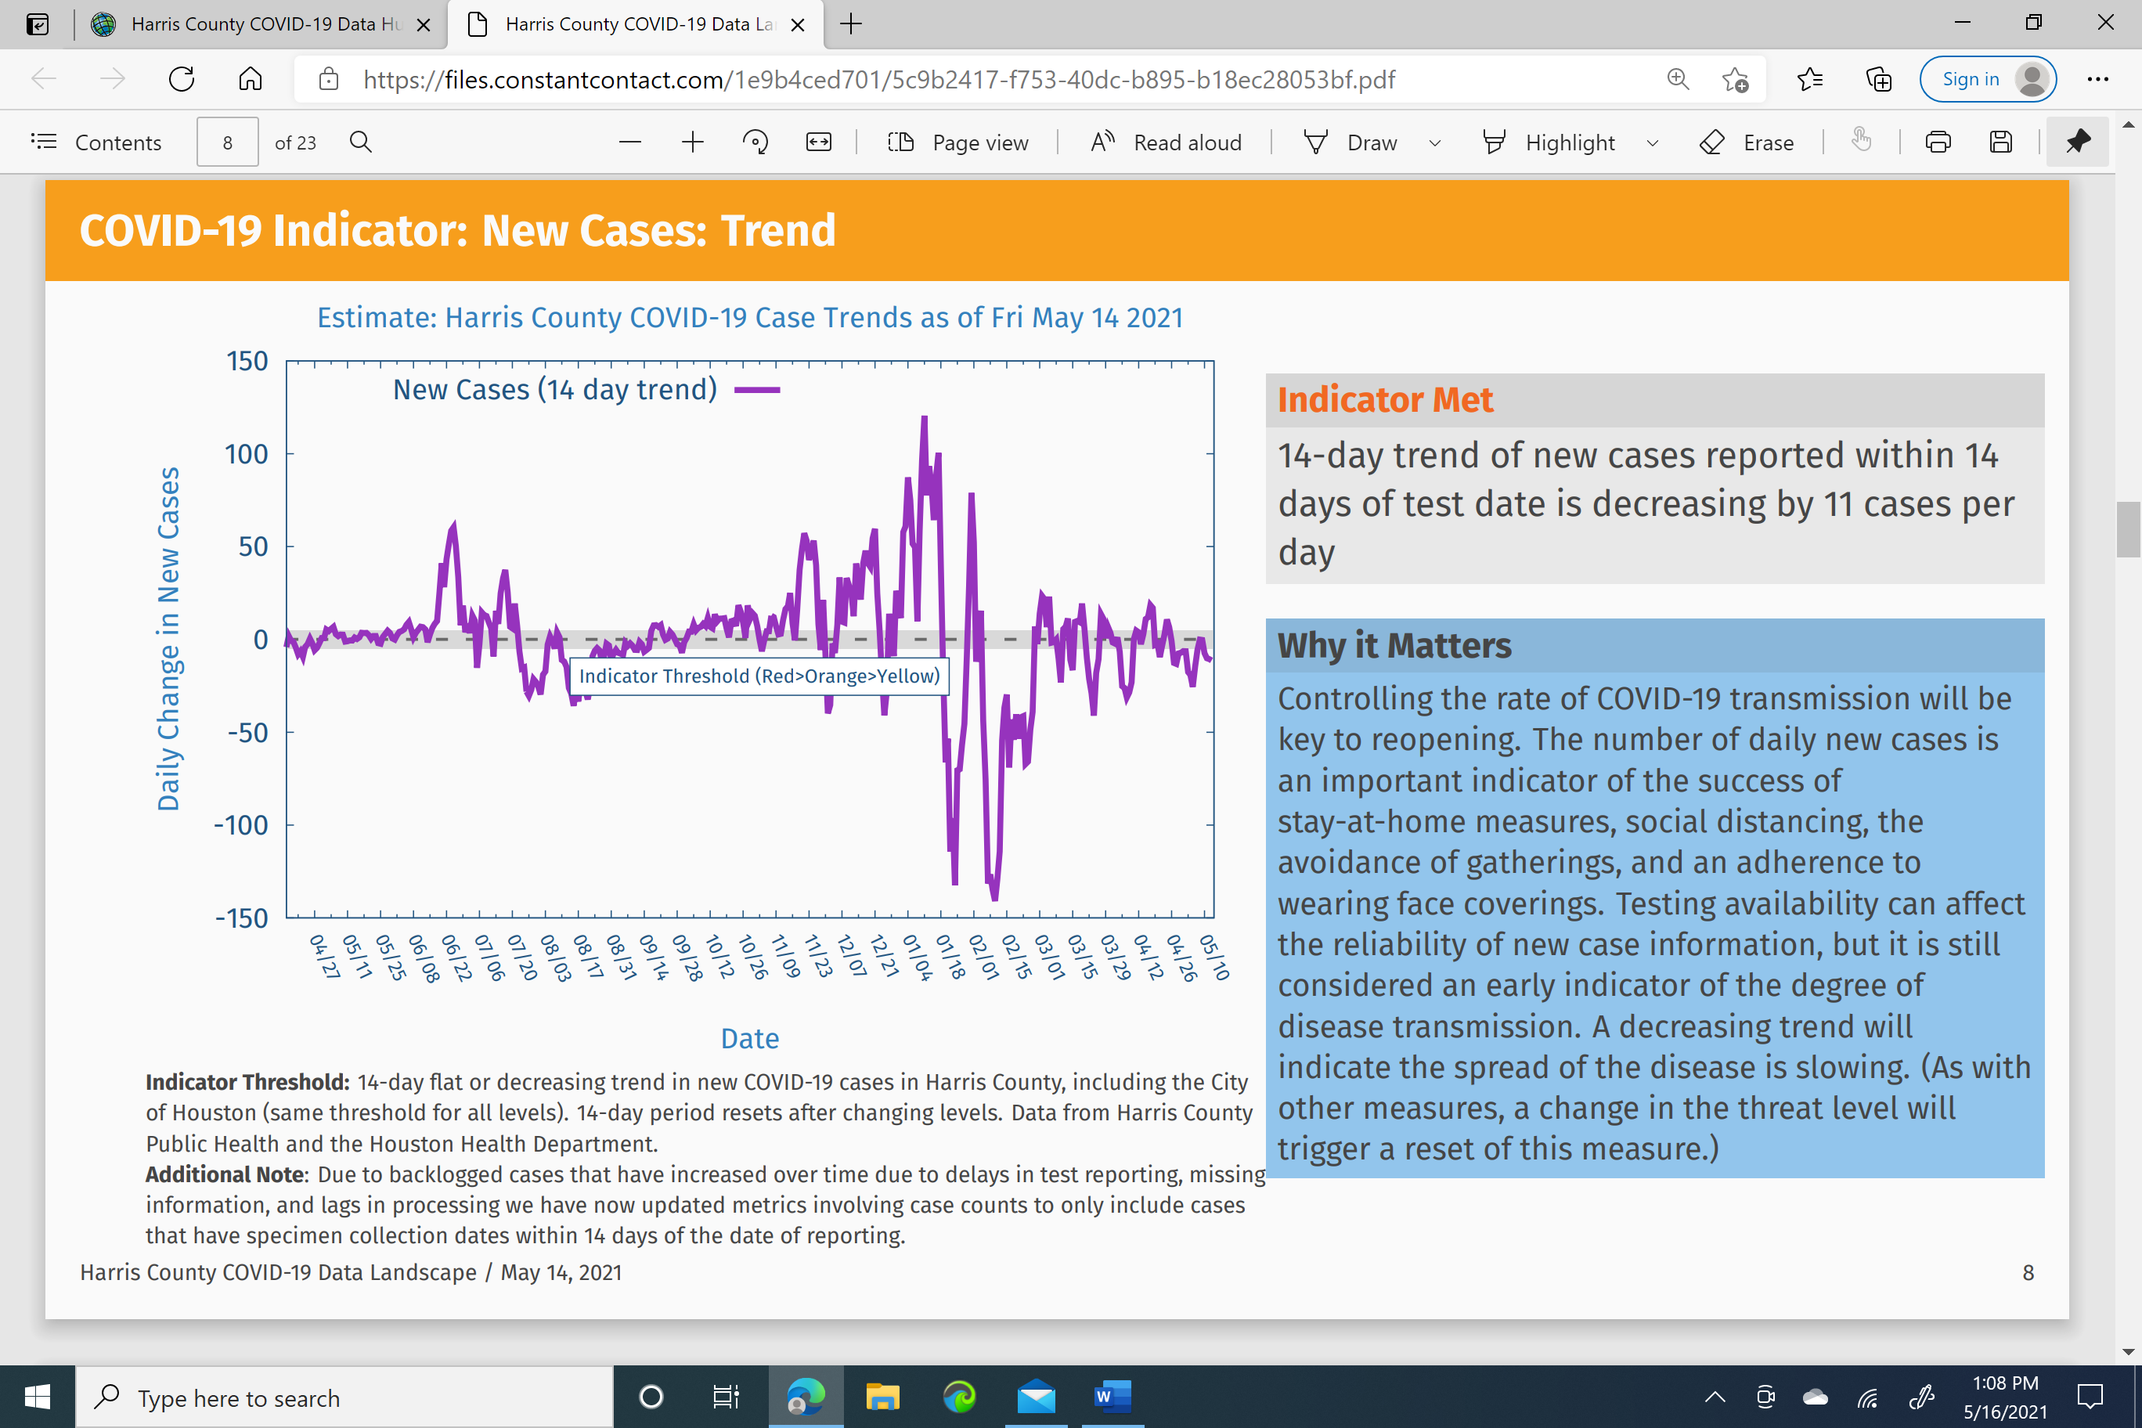
References
From the CDC…
Although fewer children have been infected with COVID-19 compared to adults, children can:
- Be infected with the virus that causes COVID-19
- Get sick from COVID-19
- Spread COVID-19 to others.
Recommend vaccinations for those age 12 and over.
From the Mayo Clinic…
Children of all ages can become ill with COVID-19. Most don’t become as sick as adults and some might not show any symptoms at all.
Some children become severely ill with COVID-19.
Children with underlying conditions, such as obesity, diabetes and asthma, might be at higher risk of serious illness with COVID-19.
Rarely, some children might also develop a serious condition that appears to be linked to COVID-19
Vaccination is 100% effective for those age 12 through 15 and 95% effective for those over age 16.
Studies are in progress for younger children.
If you or your child haven’t gotten a vaccine, keep hands clean, social distance 6 feet, clean and disinfect home, wear masks.
Don’t place a mask on a child younger than 2, a child who has any breathing problems, or a child that has a condition that prevent them from being able to remove a mask without help.

