Campus Management Committee Report to Session Regarding COVID-19 and Facilities Use
5/19/2020
Introduction and Commentary:
COVID-19 continues to be present in Harris County and does not show a sign or trend that it is going away. The Texas State Protocol for Churches “strongly encourages” the 41% of our Congregation who are 65 or older to watch or participate in worship services remotely. A substantial challenge is that we would be trying to implement rules that exclude some people from what is normally a “all are welcome” facility and worship.

Givens:
Current Status of COVID-19 Cases in Harris County per the Texas Department of Health and Human Services – There are about 175 new cases per day each day and 7 deaths per day. Virus impact peaked at 706 new cases on April 10 and deaths peaked at 8 per day. Over the past 33 days since the peak, the new cases continue to average around 175 and deaths averaged around 7 over the past 3 weeks. See the graph below published at dshs.texas.gov for Harris County.
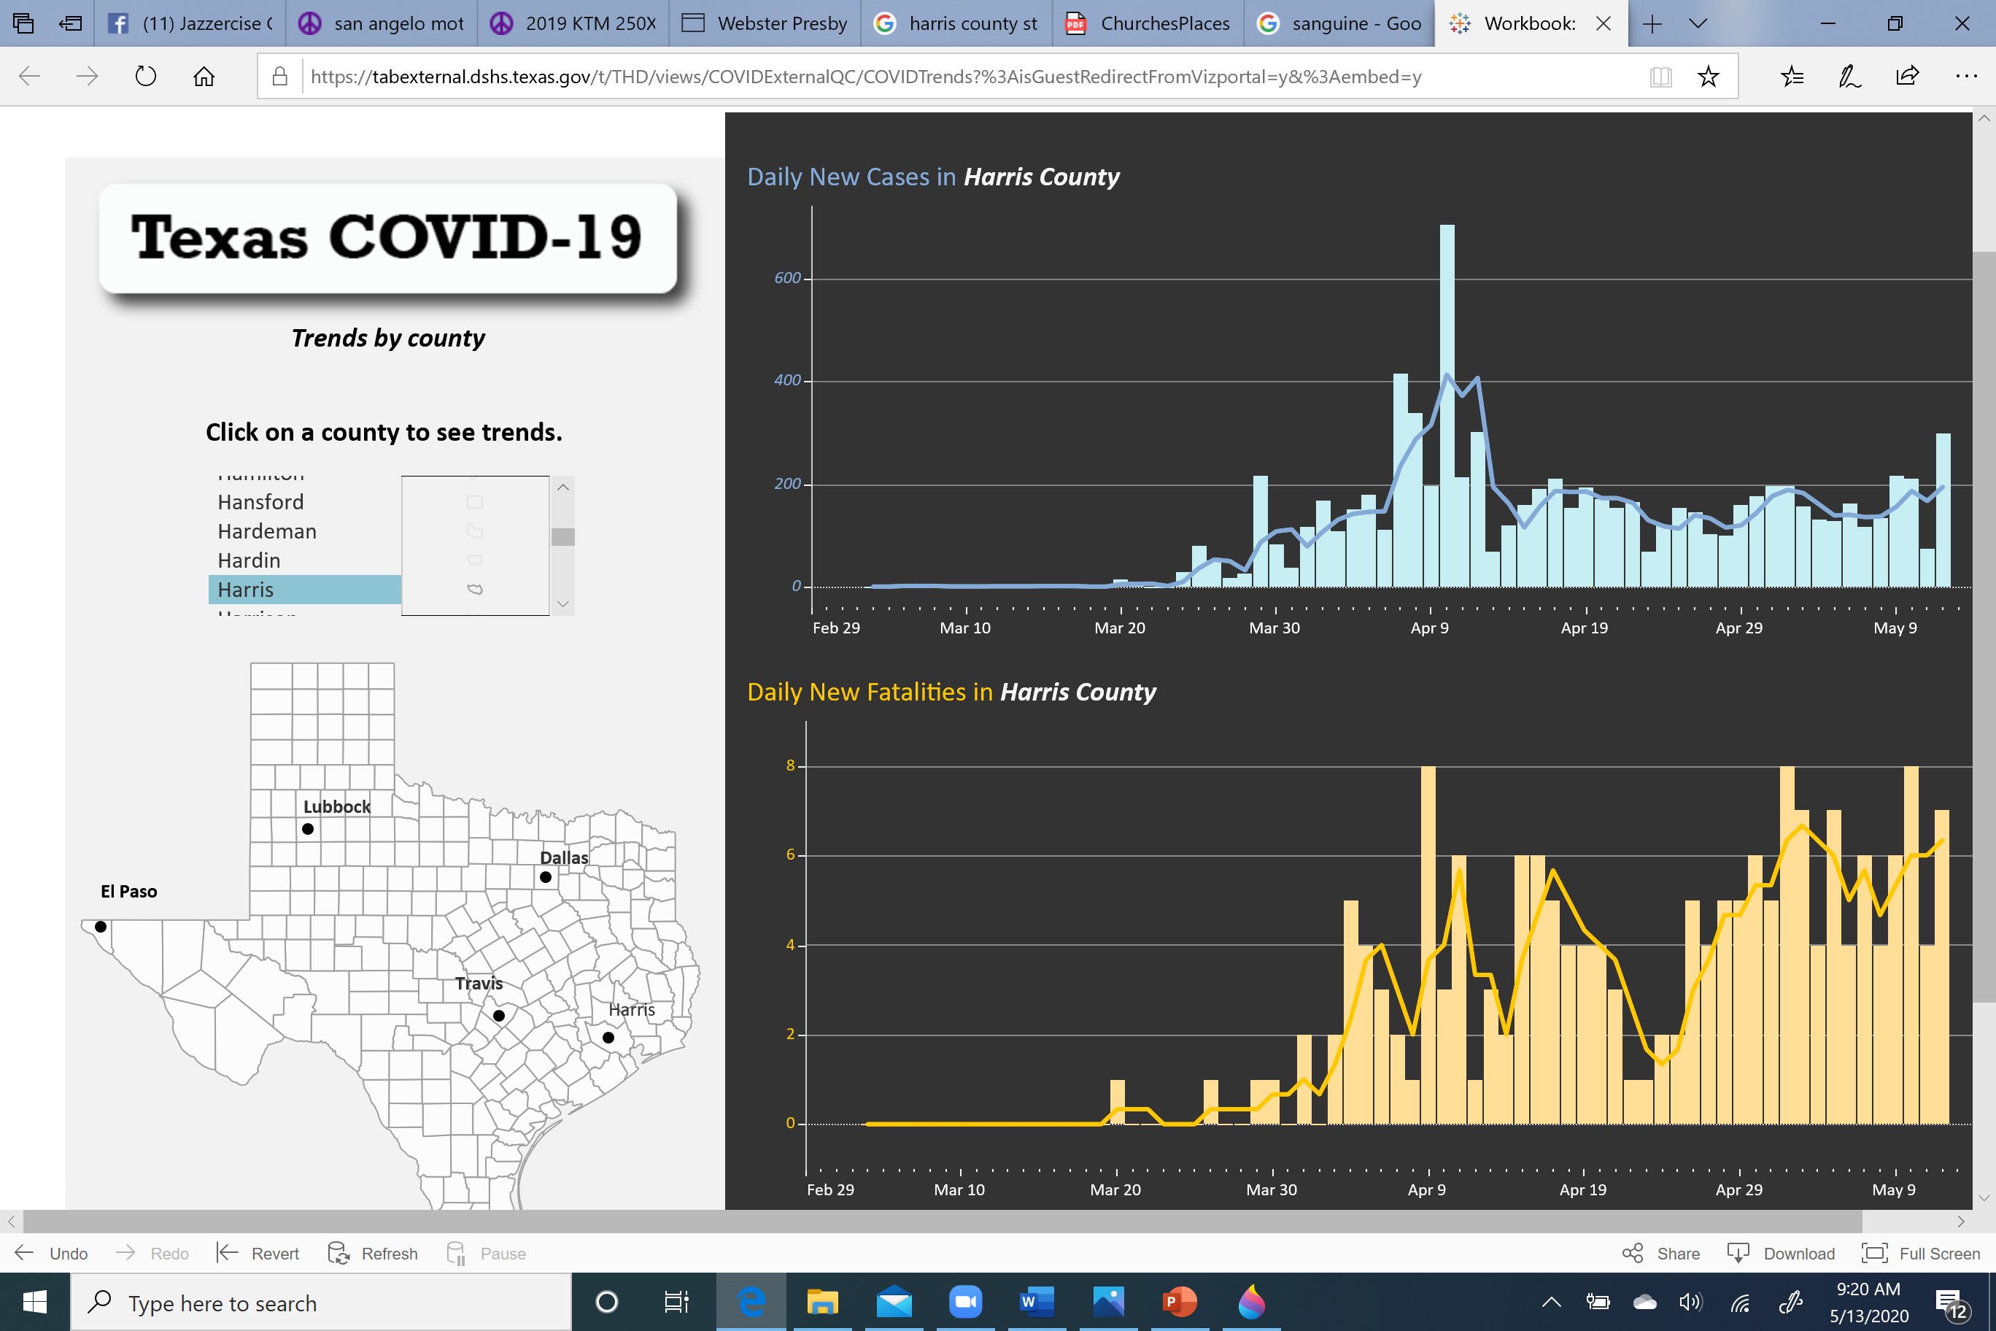
“Stay Home” was active beginning March 24th and is believed to have positively impacted the reduction of the “peak in cases.
“Open Texas” began on May 5th and the results of Open Texas relative to new cases of COVID-19 is not yet known given the incubation period of the virus.
Per the American College of Cardiology…
- The median incubation period from infection with COVID-19 to onset of symptoms is approximately 5 days.
- 97.5% of people infected with COVID-19 will exhibit symptoms by 11.5 days.
- Monitoring people exposed to COVID-19 for 14 days for development of symptoms should be sufficient to identify 99% of cases or more.
COVID-19 can be spread by asymptomatic people who show no signs of the virus per the CDC.
What are other local Churches doing? See Keith’s attachment to the Session Meeting Notice.
What about insurance coverage? Per our insurance agent, our Insurer, GuideOne Mutual Insurance Company, has indicated that if someone gets sick from WPC participation, there is no clause about a virus situation nor would there be a plan for offering a clause, Policies do not cover communicable diseases. If anyone should make a claim, our insurance agent would want to turn in a claim for the carrier to review. Taking all recommended precautions is always to best option. See information on cdc.gov or osha.gov. Examples of actions suggested by the agent are...
- Have hand sanitizer available by the door and asking that attendees use before entering
- Spacing out seating, limiting the number of onsite attendees at each service
- Post signage at all entrances: For everyone’s Safety If you have or recently had a fever, Have Cough or shortness of breath please do not enter.
- Post signage in the restrooms asking that they please (or must) wash their hands for 20 seconds before exiting

Campus Management Committee Recommendations:
If Session votes to open the Facilities today, the recommended practices to put in place would be…
No one 65 years or older should attend – Per the State Protocol. CMC does not see a viable way to exclude individuals from Worship at the Facilities at this time. If open, we should be able to be welcoming of all people who desire to worship that day.
Take the temperature of all participants and staff – Have qualified staff or volunteers take temperature for all people entering the Facility while best maintaining the 6 foot rule such as is done by Meals on Wheels.
Maintain Social Distancing – CDC recommends maintaining 6-feet social distancing to slow the spread of the virus.
No singing – Coronovirus is spread by aerosol droplets that are increased by singing vs breathing. See the following news article about a choir from the Seattle area for background. https://www.latimes.com/world-nation/story/2020-03-29/coronavirus-choir-outbreak
All must wear a mask – CDC recommends wearing cloth face coverings in public settings where other social distancing measures are difficult to maintain (e.g., grocery stores and pharmacies) especially in areas of significant community-based transmission. In addition to Social Distancing, the CDC is advising the use of simple cloth face coverings to slow the spread of the virus and help people who may have the virus and do not know it from transmitting it to others. CMC does not see a viable way to ensure all congregants wear masks.
Skip every other pew – Per the State Protocol
Families will need to manage Children to maintain Social Distancing.
For the Nursery, Note that our Nursery workers are a new mother and a grandmother of a new baby. Per the Texas HHS guidance below, prohibit any person except the following from accessing the Nursery Operation: operation staff; persons with legal authority to enter, including law enforcement officers, HHSC Child Care Licensing staff, and Department of Family and Protective Services staff; professionals providing services to children; children enrolled at the operation; and parents who have children enrolled and present at the operation. Before allowing entry into the operation, screen all of the individuals listed above, including taking the temperature of each person upon arrival at the operation each day, and deny entry to any person who meets any of the criteria in the guidance included below in Rules/Regulations.
Establish one door in and one out and follow path, exit by family unit. Staff or volunteers will need to monitor doors.
Remove all literature (Bibles, Hymnals, other papers) – Screen facilities and operators will need to be in place. Per the Worship Team, we are currently studying ways to return to projection versus bulletin use but this issue is not resolved at this time.
Sanitize all surfaces after use – Per the State Protocol. This sanitization can be done by our contractor, M&A Cleaning Service.
There will be no coffee hour or fellowship activities.
Recommend that the Facilities not be used for outside groups at this time.
Signage and other action as noted by the Insurance Company will need to be completed.

Published Rules/Recommendations:
Per the Texas Department of State Health Services, published 5-5-2020
Here are excerpts of the Health protocols for Churches/Places of Worship serving our attendees: (See the full protocol attached at the end of this document.)
- Strongly encourage the at-risk population to watch or participate in the service remotely.
- At-risk population are those who are 65 or older, especially those with chronic lung disease; moderate to severe asthma; chronic heart disease; severe obesity; diabetes; chronic kidney disease undergoing dialysis; liver disease; or weakened immune system
- Designate an area inside the facility reserved for the at-risk population, or offer a service for at-risk population attendees only.
- Ensure proper spacing between attendees, Keep at least two empty seats (or six feet separation) between parties in any row, except as follows: - Two or more members of the same household can sit adjacent to one another, with two seats (or six feet separation) empty on either side.
- Two individuals who are not members of the same household but who are attending together can sit adjacent to one another, with two seats (or six feet separation) empty on either side.
- Alternate rows between attendees (every other row left empty).
Health protocols for your employees and volunteers:
- Train all employees and volunteers on appropriate cleaning and disinfection, hand hygiene, and respiratory etiquette.
- Screen employees and volunteers before coming into the church, congregation, or place of worship:
- Send home any employee or volunteer who has any of the following new or worsening signs or symptoms of possible COVID-19: - Cough - Shortness of breath or difficulty breathing - Chills - Repeated shaking with chills - Muscle pain - Headache - Sore throat - Loss of taste or smell - Diarrhea - Feeling feverish or a measured temperature greater than or equal to 100.0 degrees Fahrenheit - Known close contact with a person who is lab confirmed to have COVID-19
- Do not allow employees or volunteers with new or worsening signs or symptoms listed above to return to work until: - In the case of an employee or volunteer who was diagnosed with COVID-19, the individual may return to work when all three of the following criteria are met: at least 3 days (72 hours) have passed since recovery (resolution of fever without the use of fever-reducing medications); and the individual has improvement in symptoms (e.g., cough, shortness of breath); and at least 10 days have passed since symptoms first appeared; or - In the case of an employee or volunteer who has symptoms that could be COVID-19 and does not get evaluated by a medical professional or tested for COVID-19, the individual is assumed to have COVID-19, and the individual may not return to work until the individual has completed the same three-step criteria listed above; or - If the employee or volunteer has symptoms that could be COVID-19 and wants to return to work before completing the above self-isolation period, the individual must obtain a medical professional’s note clearing the individual for return based on an alternative diagnosis.
- Do not allow an employee or volunteer with known close contact to a person who is labconfirmed to have COVID-19 to return to work until the end of the 14 day self-quarantine period from the last date of exposure (with an exception granted for healthcare workers and critical infrastructure workers).
- Have employees or volunteers wash or sanitize their hands upon entering.  Have employees or volunteers maintain at least 6 feet separation from other individuals. If such distancing is not feasible, then other measures including face covering, hand hygiene, cough etiquette, cleanliness, and sanitation should be rigorously practiced.  Consistent with the actions taken by many churches, congregations, and places of worship across the state, consider having employees, volunteers, and attendees wear cloth face coverings (over the nose and mouth). If available, they should consider wearing non-medical grade face masks.
Health protocols for your facilities:
- Regularly and frequently clean and disinfect any regularly touched surfaces, such as doorknobs, tables, chairs, and restrooms.
- Disinfect seats between services.
- Disinfect any items that come into contact with attendees.
- Make hand sanitizer, disinfecting wipes, soap and water, or similar disinfectant readily available.
- Place readily visible signage to remind everyone of best hygiene practices.
- If a church or place of worship provides meals for employees, volunteers, or attendees, they are recommended to have the meals individually packed for each employee, volunteer, or attendee.
- Maintain rigorous sanitation practices like disinfection, handwashing, and cleanliness when preparing or serving anything edible.

Per the Centers for Disease Control and Prevention – Interim Guidance for Coronavirus Disease 2019 (COVID-19)
The CDC guidance includes the following summary items. The full guidance is attached below.
- Consider Postponing or Cancelling a Mass Gathering considering the number of people attending who are at greater risk of more serious illness after contracting COVID-19. Older adults and persons with severe pre-existing health conditions are thought to be at increased risk.
- Consider alternatives for event staff and participants who are at increased risk for complications from COVID-19. Currently, older adults and persons with severe underlying health conditions (https://www.cdc.gov/ coronavirus/2019-ncov/specific-groups/high-risk-complications.html) are considered to be at increased risk for severe illness and complications from COVID-19.

Per Texas Health and Human Services
HHSC Child Care Licensing (CCL) urges all current providers to immediately implement the following guidance, which is consistent with the new requirements:
- Prohibit any person except the following from accessing an operation: operation staff; persons with legal authority to enter, including law enforcement officers, HHSC Child Care Licensing staff, and Department of Family and Protective Services staff; professionals providing services to children; children enrolled at the operation; and parents who have children enrolled and present at the operation.
- Before allowing entry into the operation, screen all of the individuals listed above, including taking the temperature of each person upon arrival at the operation each day, and deny entry to any person who meets any of the following criteria:
  - A temperature of 100.4°F or above;
  - Signs or symptoms of a respiratory infection, such as a cough, shortness of breath, sore throat, and low-grade fever;
  - In the previous 14 days has had contact with someone with a confirmed diagnosis of COVID-19; is under investigation for COVID-19; or is ill with a respiratory illness; or
  - In the previous 14 days has travelled internationally to countries with widespread, sustained community transmission. For updated information on affected countries, visit: https://www.cdc.gov/coronavirus/2019-nCoV/travelers/index.html(link is external).
- Require pick up and drop off of children outside of the operation, unless you determine that there is a legitimate need for the parent to enter an operation.
- Ensure that each child is provided individual meals and snacks. Do not serve family style meals.

Attachments:
Texas Department of State Health Services – Recommendations for Churches/Places of Worship
Center for Disease Control – Guidance to Community/Faith Organizations

