March Meeting
WPC Finance and Stewardship Committee
The S&F committee met 22nd of March at WPC. Members attending included Carla Yager, Ann Taylor, Jimmy Spivey, and Kevin Snowden. The primary agenda topics focused on review of spending year-to-date and the capital campaign.
Budget review for January and February
- Actual operating budget giving was $87,471.72; budgeted giving for these two months is $109,333.34, representing a giving shortfall of $21,861.62.
- Actual operating budget spending as $100,063.82; this represents spending $9,296.52 less than budget
- Discussion points
  - Campus ministry maintenance and repair spending has been hit hard
    - Important to understand that the committee’s budget for M&R is only $18,000 per year
  - Potential lags in billing
    - Electricity
    - Janitorial services
  - Youth special events and curriculum ahead of annual spending; anticipate that these are singular events that will average out through the year.
  - Working with credit card holders to submit their charges in a timely manner so that we do not get hit with late fees and interest charges
Capital Campaign
Campaign giving to date
- > $207,000 given
- No spending against the giving at this point in time
- No pledge cards returned
Home Meeting review
- Seven sessions; about 90 folks in total (estimate, we didn’t take roll count)
- Comments (in no specific order or priority):
  - Very appreciative of the 2017 giving summary
  - Strong agreement on using a third-party consultant
  - Strong desire to understand how we are going to manage and track costs
  - Agree with the bottom line: no loans, pay as we go
  - Provide a time line of when project starts / stops
  - When are we going to start spending money given so far!!!
  - Who is the right person from the church to coordinate projects?
  - Didn’t realize the organ was in as bad shape as it is
  - How do we manage projects?
  - How do we assure that we are making the right fix?
  - Are there better repair methods than what we have done before?
  - Why is the budgeted amount for general maintenance not enough?
  - Why has it been so hard to keep up with general maintenance?
Reviewed draft of the cost control / monitoring spreadsheet that will provide the basis for monitoring monthly spending for each authorized project against available monies.
Consultant meeting is scheduled for April 3 to discuss path forward and signing of agreement to engage the consultant, Story Architects, to proceed with the consultant review. Current target cost for this agreement is $12,750.00.
Miscellaneous items
- Two individuals approached to become members of S&F declined. We will continue to pursue expanding the committee in conjunction with group to provide oversight to the capital campaign.
- Documents shared in the home meetings are attached as appendices
For the committee,
DKS 25 March 2018

Appendices
- Capital task force summary statement
- Status of mortgage
- 2017 giving summary
- Capital plan overview block diagram
- Capital plan overview discussion
- Organ repair and upgrade position paper

Appendix I
Capital Planning Task Force (CPTF) summary
The members of the CPTF included Karla Bradley, Coco Motley, Courtenay Clifford, Joe Schwarz, Kathy Dixon, Reese Terry, James Kinzler, Dennis Waehner, Al Manson, Scott McNeill (CM representative until 1 Nov), and Ken Thompson (CM representative after 1 Nov.
The task force was chartered to identify capital issues threatening the financial stability of WPC. To accomplish this task, we developed a list of maintenance and improvement projects, consulted experts, and received reports from commercial building inspectors.
The findings included:
• WPC is at a good location and relocation would not change the fact that WPC is a destination church
• Maintenance of our campus has been a low priority for years and bringing the campus up to a the Congregation.
• All buildings have water leak problems, and these should be the top priority since delay will result in increased cost.
• Engage an architect for the church (such as Story Architects) to help with project specification and overall campus planning (at least for major renovations and projects and to help identify which projects can be assigned to our members to accomplish)
More details about the CPTF findings and recommendations can be found in the CPTF report provided to the WPC Session.

Appendix II
Mortgage on Sanctuary
The current balance on the sanctuary as of January 2018 is $141,697.38, monies collected to date to pay to the principal will result in a balance of 128,336.38.
- We received pledges for the 2018 year for the building fund at a total of $41,336.38.
- And we will pay $52,229.52 in principal and interest charges out of our operating account in 2018.
- With those planned payments and pledged gifts, the balance of the mortgage at the end of 2018 should be approximately $50,000.00

Appendix III
Giving in 2017 above the Operating account
In 2017, the congregation of WPC was very generous. While much focus is given to the operations giving through gifts, WPC members gave to other areas of the church and missions. Just a reminder gifts to the operating account totaled $662,773.62
- Building Fund – In 2017, donations given to pay down the mortgage principal totaled $160,448.78
- Mission giving - In 2017, donations to WPC totaled $77,106.07 for specific mission giving. This including Presbyterian Disaster Relief for Hurricane Harvey, Gifts of Joy, Peacemaking, Pentecost, and One Great Hour of sharing and many other worthy causes.
- Lastly, as we started communicating about this new Capital Campaign, the giving in 2017 was $182,530.23
Those three areas, building, mission, and capital campaign totals $420,085.08 of giving above the operating giving.

Appendix IV
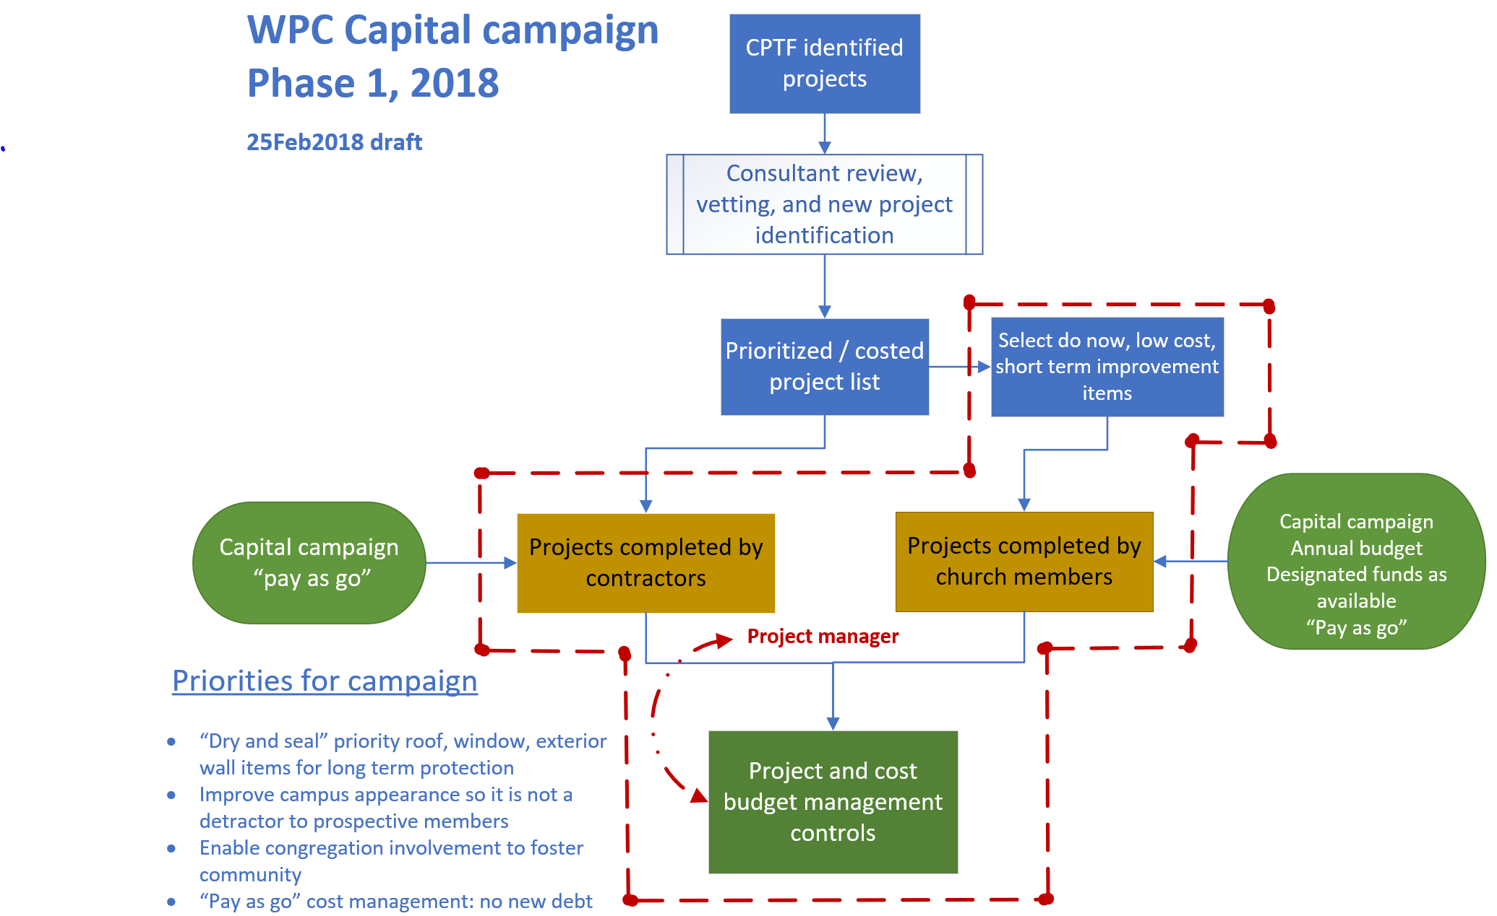

Appendix V
WPC Capital Campaign, Phase 1, 2018
The WPC 2018 capital campaign consists of four key components
- Financial commitment from the congregation supports phase 1 activities
- Independent third-party consultant provides analysis of CPTF project lists, suggests project additions or clarification to the list based on further inspection of the facilities (termed as ‘discovery’ or add ons following more detailed analysis), provides additional scope to projects as appropriate, and cost estimates for key projects not fully estimated by the CPTF report
- Finance and Campus Management, or ad hoc committee, collaborates to prioritize a project list based on findings from the consultant for Session review and full consideration of funds available to support execution of the individual projects by contractors or congregants
- Finance provides project cost management review and control through reporting to Session and the congregation on progress against the “pay as funds available” conceptThe framework for executing projects on the prioritized project list includes
- Spending against the projects will conform to the approved action of Session on the CPTF plan and the existing policies and procedures of Session and its committees with due consideration of modifications as needed
- Recommendations for contractor or member groups executing specific projects from the prioritized list will be managed by the Finance / Campus management committees (or ad hoc committee) based on project scope, project complexity to complete, assurances of the correct skill levels of participants, clear attention to safety and health considerations during project execution, and available funding; intent to designate a project manager to oversee activities.
- Select do now, lost cost short term improvement items may be completed by church members given careful consideration of the requirements noted in the previous two bullets and approval.
- No new projects will be authorized to start if sufficient funds are not available to fully complete projects already in progress and the cost of the new project - [pay as go, no new debt]Current activities
- Developed plan for home visitations to explain plan and seek financial support
- Received positive commitment from consulting architect, first approached in 2017, to re-engage with WPC
- Began review & selection of low cost, short term improvement items to begin planning
Risks
- Financial commitment from the congregations is not sufficient to meet revised do now projects estimate
- Consultant costing for do now projects not estimated by CPTF adds significantly to total costs
- Consultant identifies new projects meeting ‘dry and seal’ goal not identified in CPTF list
- Project add-ons during discovery expand the scope of the repairs

During the capital campaign, consideration for retiring the mortgage debt, completing the full list of do now / do soon projects, and funding for an upgrade to the organ may also be considered given level of financial support from the congregation.

Appendix VI

Organ upgrade and refurbishment proposal
Webster Presbyterian Church

Proposal
This project proposes to upgrade and refurbish the Moller (1977) sanctuary organ to full operational capability and add new ranks to expand the musical range of the instrument. The primary scope is the upgrade from the original controls to digital components, addition of pipe ranks increasing the power and varietal sound range of the instrument, and refurbish and repair remaining components to like-new status as appropriate.
Highlight specifics for the upgrade
- Increase the size of the instrument by five ranks of pipes and to 48 stops
- Upgrade the ‘heart’ of the organ to industry standard Peterson IPC 4000 digital processor
- Repair or refurbish current chests and pipes to allow full musical range of the instrument (chimes, flute, trumpet, etc. sound capability)
- Modifications, repairs, or refurbishments to most of the existing components
Note the current proposal contains 22 line items.
Background
The sanctuary organ was originally designed to match the acoustics of the former sanctuary, now the Fellowship Hall. Moved to its current location, maintenance of the organ through the years provided a functioning instrument. However, due to budget restraints, key maintenance and any upgrades were purposely delayed. The result is that a significant number of components in the grand, swell, and pedal ranks are no longer functional. The organist must limit the musical repertoire to match the capability of instrument, modify the delivery of the composition, or simply play and get the results the instrument can deliver. The success in musical experience is result of the skill of our organist to best match these constraints. As noted above, the organ was designed to fit the previous sanctuary. It is adequate but yet undersized for the current sanctuary. Adding five new ranks of pipes provides an instrument better fitted to the acoustical allowances of the current sanctuary.
Project cost
Our target budget is $150,000. This value is based on the elapsed time since receipt of the 2016 quote of $136,820.

Organ upgrade and refurbishment proposal, continued
Other options
Do nothing | No current cost | Not considered viable long-term solution as a significant portion of the organ is not functioning now and the rate of deterioration of the organ may significantly increase resulting in increased annual costs to maintain reduced or minimal capability
Used pipe option | $114,500. | This quote was provided in 2016 as an alternative to new pipes. The inventory of used & refurbished pipes available at that time may have been depleted.
Partial refurbishment | $55,500. | This quote was provided in 2016. The scope is to upgrade to Peterson ICS 4000 and make targeted repairs to maintain organ. The scope does not include increasing the number of pipe ranks nor other component improvements
Replacement | $1.5 to $5 million | We do not have an actual quote on a new organ designed to fit the sanctuary. This is a best guess range estimate and is highly dependent upon the scope for the new instrument [size and features].
Current state (partial list)
- Great
  - Flute 2' sometimes works
- Swell
  - losing notes in the Swell in the 8' principal
  - Gedeckt 4' sometimes works
  - Oboe has various pitches that don't work or sound weak
- Pedal
  - Bourdon 16' doesn't work at all
  - Principal 8' doesn't work at all
  - Trumpet 16' has a buzz on certain notes
  - Great to Pedal coupler - the Principal 8' from the Great doesn't work in the pedal
- Worn stop tabs
Other points of consideration
- Availability and cost of spare parts for older technology instrument
- Organ technician’s comment on current state: “wow” and “why did they do that” [commenting on state of previous repairs]
DKS 04Mar2018

