To the Session of Webster Presbyterian Church,

Greetings in the name of our Lord, Jesus Christ! The past month has proven many things, but most of all, the overwhelming acceptance of the budget for the coming year. Committees continue to shine through with goals being set, and visions for new and continued ministries being the focus.

The weather has not disappointed either! (Sarcasm) Another cold front managed to make its way into our midst, but that merely was a “speed bump,” for us!

I remain thankful to Michael Cooper for filling in for Liz who was out once again for surgery. I truly value the confidentiality of all those who have helped in the office, and for those who have taken on additional responsibilities during her absence.

I would especially like to spotlight Glenn and Geri Foster who served as, not just the organizers and hosts, but were the reason why we were able to enjoy a concert earlier this month by DUO DRAMATIQUE, the Houston-based renowned violin-piano duet, featuring violinist Dominika Dancewicz, and pianist Andrew Schneider. It was an amazing event and wonderful way to kick-off also the latest art display (War and Peace along with the quilts that are part of the Sacred Threads display). A very moving experience for all those in attendance.

I would especially like to thank the property folks for building a wall that allowed for artwork to be displayed in a way that it provided a safe space for those who may have been affected by the nature of the artwork.

The music programs continue to be a masterfully orchestrated part of worship that I truly enjoy and moved by. Thank you to all of you who continue to contribute your time and talents to this important ministry of the church!

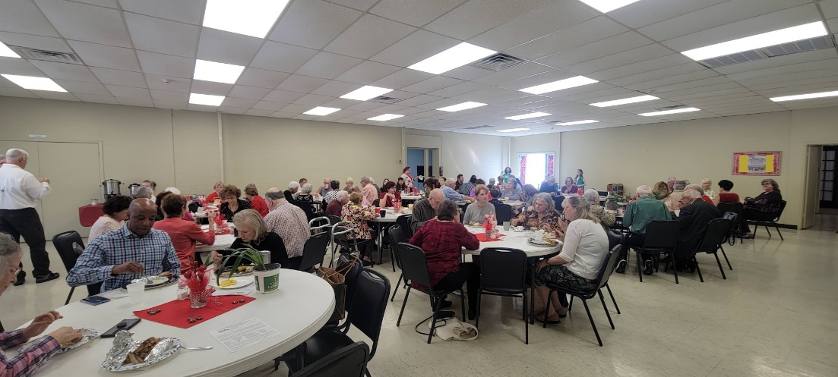
The men of the church did an awesome job preparing breakfast for the church one Sunday, while the youth of the church focused on making Valentines for folks who might be shut in or needing some additional support during the holidays. There are also Girl Scout Cookies available! And we are looking forward to celebrating Scout Sunday in a few weeks.

The folks who care for the AV equipment in the sanctuary have gone out of their way to move the equipment to a new location. What a difference it has made! On another note, the Breaker Box room in the hallway next to the Parlor still contains several electronic items that the Fire Marshall has deemed to be dangerous. We need to address this and have the items removed. If they are being stored for someone else, or reason, lets address and resolve the concern the Fire Marshall has.

Jennifer and her group on Wednesday continue to provide meals at an affordable price, and I know it has been a huge help to my family as my spouse now has joined the choir and that gives us an opportunity to be more involved in church activities.

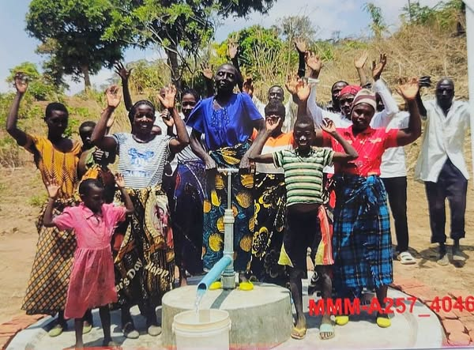
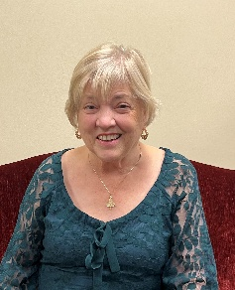
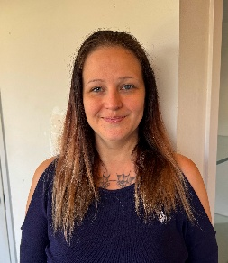
We did welcome two new members over the past month. The Welcome Committee introduced us to Jerica Bevard (left) and Priscilla Ennis (right). We look forward to getting to know them better and sharing the WPC Community with them!

During Mission Meeting / Retreat, we learned that a new well was installed on November 22, 2024, in the village of Mbachazwa Mgemezulu, Malawi. This will provide fresh water daily for the forty people who live there! Way to go!

A busy week ahead with WPC hosting Family Promise. Be sure to check the schedule for items that may still be needed.

I wish that I could list all the things that are presently happening, but we are a busy group of people. I continue to pray for this season and continue to give thanks for the opportunity to journey with you currently.

Stay in God’s grip!
Todd

Rev. G. Todd Williams, MDiv., APC

