Webster Presbyterian Church
Stated Zoom Meeting of Session
February 22, 2022 at 7:00p.m.

Present: Keith Uffman, Kathy Dixon, Diane Kane, Pat Koester, Jamee Wilson, Jeannette Booher, Michael Bradley, Kristy Russell, Michael Cooper, Kevind Snowden, Dan Walker, Ed Tobia, Judy Ota, Al Strahan, Gary Mossman, Ralph Faxel, Tamar Wasoian, Erik Kinzler,

Absent: Mary Lawrence, Nancy Steger

Visitors: Sandy Dwyer, Patty Eng, James Kinzler

Quorum established at 7:02 pm

Opened in Prayer by Parish Associate Dan Walker

Servant leadership: Practice run of what will be said to congregation at Sunday’s meeting (i.e. Personnel; Budget; AV; Art Therapy) (allow time for questions and comments to anticipate questions from the floor)

Omnibus Motion
Approval of Agenda—Motion by Michael Cooper

- Approve minutes of the last regular meeting—Ralph Faxel made the motion to approve
- Approved by Common Consent

Clerk’s Report
No changes in membership since last report
- Elect 3 commissioners for March 18, 2022 Presbytery meeting—This was not done because we changed the order of business to allow visitors to speak first

Treasurer’s Report:
Created Christian Education as Budget Item, took out line items that had no money in them, balanced the budget for 2022 @$581,800

Pastor’s Reports:

Keith—health is improving; figuring out how to do the work of the church with fewer committees; merged fellowship, family ministry, and adult ed into Christian Education Committee; sent out emails to new officers to begin writing faith statements as part of officer training; will be talking with elders about committee assignments within the next couple of weeks

Dan—has been working with the deacons to provide “in-home communion’ to shut-ins; is talking with visitors about their interest in joining the church, intending to set up a zoom opportunity for an open door class to teach about WPC history and general “what is a presbyterian”

Motions: (actual wording of motion)

For support or update by the Session…
WPC COVID Update – February 2022
Folks, some have asked about when we can be in the Sanctuary without masks. The trend looks good for us to get there soon. We remain connected to Interfaith Ministries group calls on the status of COVID in our area via Nancy Steger, Diane Kane and James Kinzler. Our Campus Management and Worship and Music Committees look at this status and make recommendations to Session on COVID actions. A key measure is the daily new COVID positive cases for the Greater Houston Area. Average Daily New cases for the week dropped from 3883 to 2305 in the past week. The medical community believes COVID is under control when we see rates stay below 200 new cases per day for 2 weeks. We hope we are just weeks away from that point. See the graphic below for reference.

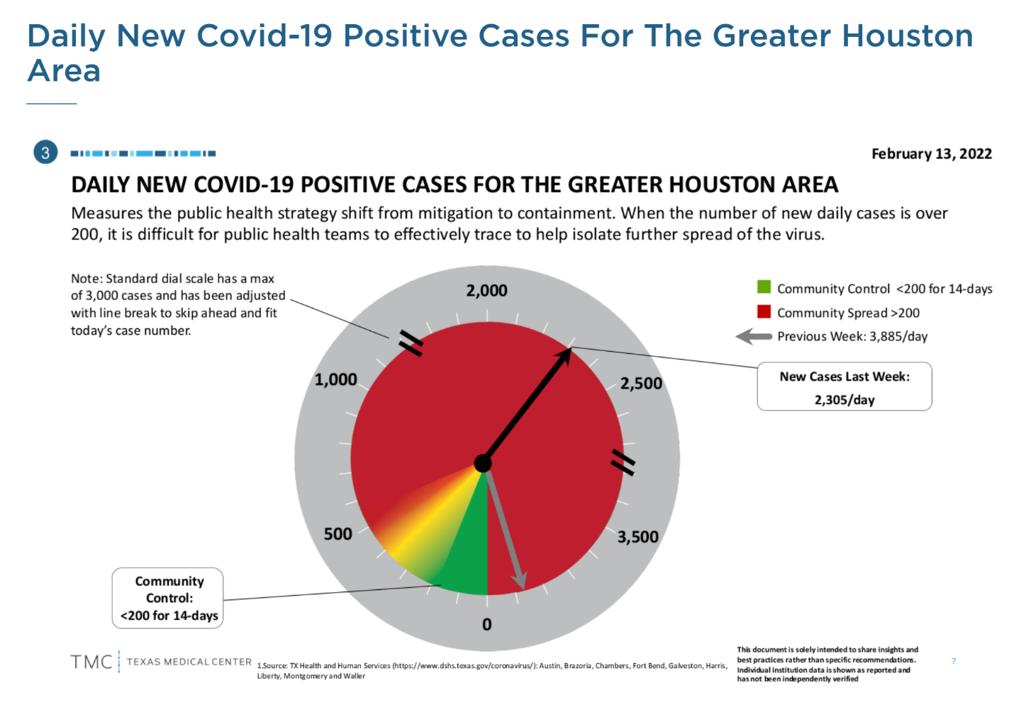
As COVID experience is different for each person in the congregation, please be respectful of others and wear a mask in and out of the sanctuary after we reach the community control point for 14 days. We will return to masks in and out and then you choose what you wish while seated with your group. Remember that we are an “at risk” community. We are thankful for our large sanctuary that allows us to spread out and take masks off when seated. We are also thankful for our AV crew that provides for youtube access to our worship service online.

Mission:
The Mission Team presents the following omnibus motion for approval by Session:

The Mission team presents this omnibus motion to include the following mission fund-raising activities for approval:

McWhirter
- Food Drives – Assist with local hunger relief within our community by participating in conjunction with McWhirter to help supplement over 100 families during Spring Break (February) and Thanksgiving Break (October).
- Back to School supplies – funds will be raised to assist in providing school supplies to Children at McWhirter
- “Gifts of Joy” – funds raised will purchase gifts for McWhirter Elementary and Brookside Intermediate students whose families are unable to provide holiday gifts. Fund drive begins in November and ends December.

PC(USA) Special offerings:
One Great Hour Sharing special offering collected in April
Pentecost special offering collected in May
Peace and Global Witness Offering – a PC(USA) special offering collected on World Communion Sunday (October). WPC will keep 25% of the funds donated and distribute those to PC(USA) mission partners working in Peru; the balance to be remitted to PC(USA).
Joy Offering – a PC(USA) special offering, collected on Christmas Eve and remitted to PC(USA)

Seafarers Gift Boxes – WPC members fill shoeboxes with personal items and non-perishable gifts for seafarers traveling through the Port of Houston during the holidays. This year’s effort begins in mid-September and culminates in a “Blessing of the Boxes” on October 10.

ICM
- Furniture and Fund drive – furniture and funds to be raised to assist Interfaith
- Caring Ministries in August with providing furniture and monies to help with the ICM Resale Shop.
- Christmas Store – WPC provides the space and volunteer opportunities for WPC members to participate in this long-standing event with Interfaith Caring Ministries, during the first week of December. No fund drive is anticipated; however, the congregation will be solicited to provide unwrapped gifts.

These funds are intended to augment the annual benevolence budget of the congregation.
Rationale:
Background: During the year the Mission Team has many mission projects that include a fund-raising component. All the fund-raising activities identified in this motion have been approved by the Mission team. These fund-raising opportunities are long standing activities that WPC has participated in and that Session has approved in the past.
Mission Team has put forth the motion above and requests Session approval for fund-raising activities for the remainder of the 2022 calendar year.
Passed by general consent

Report from Committees: (reports posted in session webpage, do not require action)

Unfinished Business:

Spiritual and Pastoral Concerns:
Praises: John Dewey, Bob Hill, Sandy Mossman
Prayers for Healing: Kathy and Bill Dixon, Keith Uffman, Dan Walker, Mary Lawrence, Ron Wenninger, Jeff Rorrer, Geri Foster’s sister and brother-in-law,
Misc: Jeannette Booher on the death of her uncle, Ruth McDonald, Kent Frohme, Roy and Lois Phillips, Ian Russell

Motion for Adjournment 8:55 pm and Closing Prayer by Pat Koester

