Average Attendance 274 November 2010
Average Attendance 500 November 2011

Outreach is about spreading the message outside of the congregation; to connect our ideas to other groups and the general public. Unlike marketing it does not revolve around a product or service. The opportunities and activities our church provides are excellent. The job of Outreach for this organization would be much more difficult if it weren’t so. Given that, there is no need for the Outreach team to look inward for making changes, but rather to take what we’ve got just the way it is and spread it out to the community. We will look inward only to study who the congregants are and what programs we have to offer. We will look inward to educate the congregation on the task of asking people they meet to come join us.
The team’s focus will be outside the church. We will target our core demographic as well as the general public. We will not be rewarded for trying, but only for achieving these numbers.

- Goal is to build the kingdom of God.
- Objective is 500 attendees in the sanctuary.
- The key performance indicator (KPI) will be an attendance average of 500 per Sunday (total of both services combined) for representative month, November, 2011.
- The vision is to let people know WPC is here, it’s open and welcoming, and they are invited!

The committee will be a loose organization of specialist consultants in marketing and advertising. The emphasis will be on the numbers in attendance. Speed will be essential because the members of the committee cannot afford to take six months to become comfortable with their roles. By then the tenure will be half over and being comfortable in a position reflects a status quo attitude. A status quo attitude will be reflected obviously in the attendance numbers. The team will develop a group of enthusiastic outreach group that attends local festivals and parades, and works to bring outreach events to WPC.

Achievements to date:
- Created Cafepress apparel and gifts store using existing logo.
- Engaged graphic artist for custom tee-shirt designs.
- Progressing Lenten season postcard.
- Website Facebook Like button (see page 2.)
- Mardi Gras Family Parade in Galveston
- Private label water bottles (Parades, Marathon, Festivals in Friendswood & Clear Lk Park)
- Wrote Outreach contribution to Newsletter

March 2011
- Distribute Lenten postcard
- Develop committee
- Develop team
- Brainstorm ideas
- Contact Mission & other teams for tee-shirt development
- Order water bottles
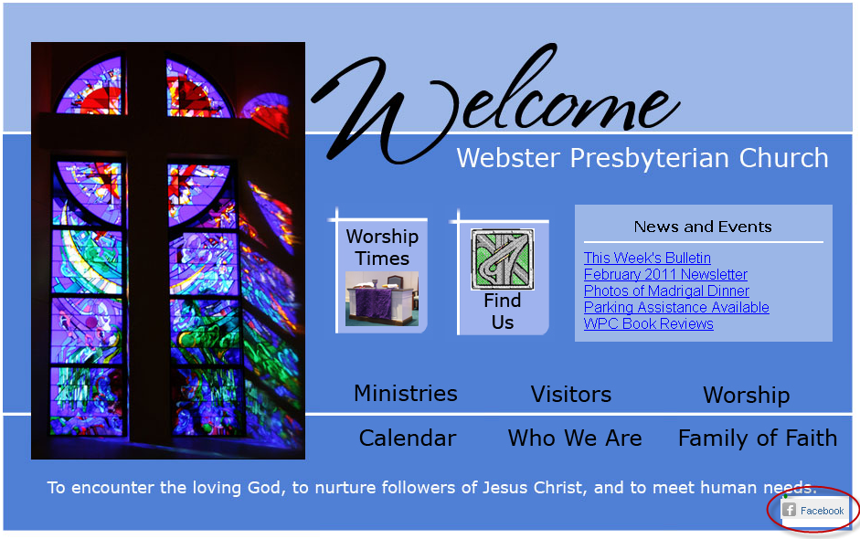
Facebook’s “Like” Button on Website

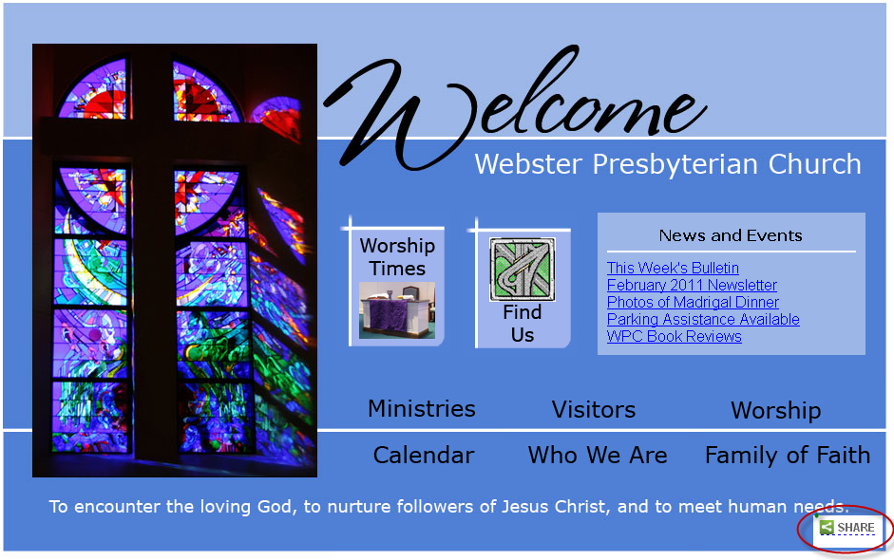
Requested Adding Social Networking Feature

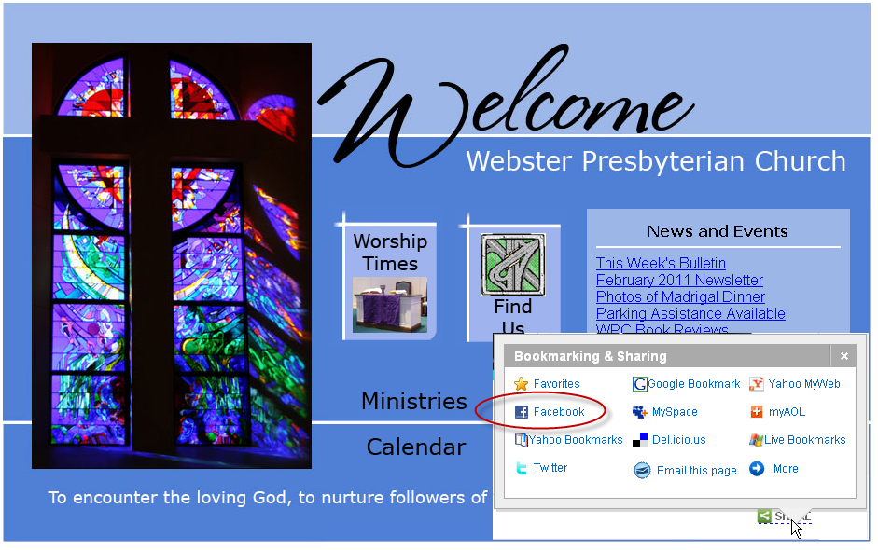
Facebook’s “Like” Button along with other social networking sites.

