Viewing / Modifying Time & Talent for members

Look up the member using the standard directory lookup and if you have webteam access you’ll see the links in the red box below.



From there you can modify their T&T.

Viewing Time & Talent for ALL members

The formatting is horrible, but the data is there
Go to Session webpage and find this link:

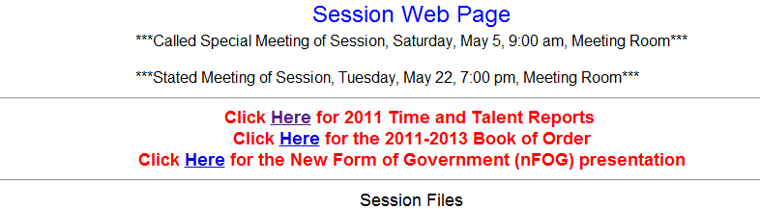

Clicking that will get you a report of all members T&T:
