Executive Summary:

A subcommittee of the Earth Care team is recommending that WPC enter into a contract with Covenant Solar LLC to install 107 solar panels on the roof of the Sanctuary. The system will supply 28.6% of our electrical power needs. Under the terms of the contract, WPC will lease the system from Covenant Solar LLC for a 15 year period. During the lease term, there will be no additional cost to the church, as the lease payments will be offset by the savings in power cost. After 15 years, WPC will own the system and will realize the full savings in power costs for the remainder of the system’s 30+ year life. The benefit of having Covenant Solar own the system initially is that they can take advantage of the 26% federal tax credit, thus reducing the cost of the system to WPC

The first-year lease fee is $6,788, which is to be paid $1,697/quarterly. The lease fee will increase by 2% per year. The projected savings over 30 years is calculated to be $172,000.

WPC is responsible for routine maintenance, which is projected to be minimal. The routine maintenance duties involve cleaning the panels which will be mainly done through wind and rain. The panels and inverters all have equipment and performance warranties. WPC will provide the insurance coverage. Our insurance provider indicated that it will not increase our premiums.

The sanctuary roof was replaced a couple of years ago. The anchoring of the panels will use “Iron Ridge Flashfoot 2” connectors which are self-sealing. The installer will fix any leaks caused by the installation of the panels. The anchors are rated for a 150 mph wind, equivalent to a category 4 Hurricane. Rooftop Solar panels have been known to protect the shingles from sun and rain damage.

Using more clean, renewable energy sources provides a tangible display to visitors, to our congregation and to the world of our commitment to the care of the Earth.

Proposed layout for the WPC Solar system.

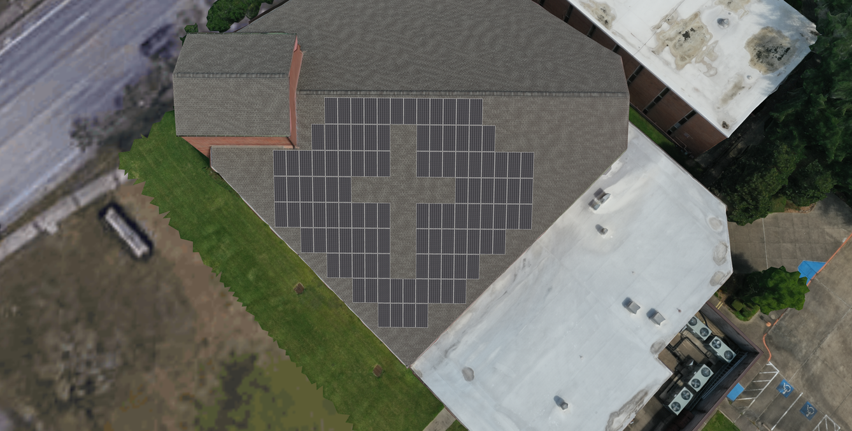
Detailed Proposal, justification, and Q/A:

Proposal:

A subgroup of the Earth Care team is seeking permission to install 107 solar panels on the roof of the Sanctuary, routing the power to the Sanctuary and the Administration Building. The system will supply 47.1 KW of electrical power, 28.6% of our average electrical needs for the first year of operation. WPC will lease the system from Covenant Solar over a 15 year period, making it “cost neutral” for the first 15 years. Then, WPC will receive the total cost savings from the system for the remainder of its expected 30 year life

Basis:

There are many biblical references that can be used to describe God’s intention for how we should care for the Earth, our home. Psalm 24 begins “The earth is the Lord’s and all that is in it, the world and those who live in it”. Genesis 2:15 reads “The Lord God took the man and put him in the garden of Eden to till it and keep it.” This world is not ours to do as we please, it was given into our care to be sustained and in turn sustain us.

In the last 50 years, we have discovered that this planet of ours cannot be sustained if we continue to change the balance of nature that has been in place for millennia. Scientists have outlined the path we need to take to halt the changes we are making to our climate; the main concern is how we create the energy our society needs. Using more clean, renewable energy sources will help bring our world back into balance.

Part of Webster Presbyterian Church’s mission statement is to “create a more loving, affirming, just and sustainable world”. This proposal to install solar panels at WPC directly aligns with our mission.

Benefits:

- This project would demonstrate our commitment to our mission statement.
- The panels would be a tangible display to congregants, neighbors, and visitors of our commitment to the care of the Earth.
- WPC’s current average cost of electricity is $0.115 / KWH. The estimated cost of electricity from solar panels is $0.098 / KWH for the first year. WPC is projected to break even over the 15-year contract life and enjoy significant savings for the remaining 15 years (Approximately $172K over 30 years).
- Potential to lower our transmission rate cost (TDSP) from CenterPoint energy in the summer months. The transmission rate is based on the peak usage for the month, solar panels will reduce the peak value for the summer months since the peak occurs during daylight.

Background:

Covenant Solar LLC installed the solar panels at St. Philip Presbyterian Church in July 2020. Covenant Solar is a company that can claim the 26% tax credit for solar panels from the US government and pass the savings to churches, reducing the installed cost. The WPC Earth Care Team was made aware of this arrangement through the Presbyterian Earth Care Network. A group consisting of Joe Schwarz, Ralph Faxel, James Kinzler and Ed Tobia have been exploring the potential for installing solar panels since the Fall of 2020.

Q&A:

- How much will this cost?
  - The first year lease fee is $6,788, which is to be paid $1,697/quarterly. The lease fee will increase by 2% per year. Again, the lease amount was calculated to directly match the savings on our utility bill. We currently have a fixed rate for the electricity we use, the variability comes from the transmission cost portion of the electricity bill. At the end of our contract period with Green Mountain Energy, we think there is a good probability that the rate for the electricity we use will increase. This project is a hedge against increasing electricity rates.

- What happens after 15 years?
  - The ownership of the system is transferred to WPC at the end of 15 years.

- Will we owe any money at the end of the lease?
  - The contract wording does not specify an amount due at the end of the lease. The reason for this is that the lease must be termed an Operating lease (meaning the ownership is with the Covenant Solar) rather than a Capital lease (meaning the ownership is with WPC). The ownership must be with Covenant Solar for at least 5 years to receive the 26% tax credit.
  - Covenant Solar can reclaim the system at the end of 15 years, but they would have to remove the system and restore the roof to original condition. This would more than likely cost more than the 15 year old system is worth. So, Covenant Solar is expecting the transfer cost to minimal if not zero.
  - Other options for the transfer costs would involve WPC paying off the lease amount early, as long as it is owned by Covenant Solar for at least 5 years.
    - WPC could take out a “Restoring Creation Loan” through the PCUSA, which is now at 2% with no initial costs.
    - WPC could pay off the lease from the general fund or a special fund. If we are able to pay off the lease earlier, then we would capture all of the savings from that time forward.

- What happens at the end of 30 years?
  - The system efficiency will decrease over time. It is predicted that it will degrade by about 0.5% per year. We can continue to use the system past 30 years for as long as it is practical to do so. At the end of 30 years, the power output is projected to be 40.7KW (about 86.4% of original output).

- Will the system always provide the same amount of power (47.1 KW)?
  - No, all solar panels degrade in efficiency over time. These panels are projected to degrade at 0.5% per year. At the end of 30 years, the power output is projected to be 40.7 KW (about 86.4% of original output).

- Why don’t we make the system larger and get a higher savings?
  - The system is designed to cover our baseline electricity demand. A larger system would mean selling some electricity back to the grid. We cannot sell electricity back to the grid at the same rate we pay for it. This would mean a loss for any excess over 47.1KW and a smaller payback over the long run. We can explore adding more panels to the system if the state laws change to make it more equitable between the price paid and refund received.

- Who will maintain the system?
  - WPC is responsible for routine maintenance, which is projected to be minimal. The main maintenance duties involve cleaning the panels which will be done through wind and rain. The panels and inverters have limited warranties. Each panel is monitored individually, so if a panel is underperforming it can be found and replaced. Most of the time if a panel or inverter is underperforming it would be replaced during the warranty period. Project cost includes a plan for WPC to escrow $250/yr to cover routine maintenance.

- Is the system covered under a warranty?
  - Solar panels are covered by manufacture warranty on the performance, or electricity output. In the case of Aptos, the brand proposed for the Webster Presbyterian project, the manufacturer warrants that the system will perform at 85.1% of its original output at the end of 25 years. It operates on a sliding scale during the lifetime of that warranty.
  - The Solar Edge inverters have performance warranties offered by the manufacturer against defects and operating problems for 12 years. In addition, the installation contractor offers a 10-year workmanship warranty that addresses any errors or issues that arise as a consequence of the installation process. If these are going to arise, which is unlikely, they should show up in the first year of operation.
- How tough are the panels themselves? Will they break during a hailstorm?
  - The panels go through intensive testing and can withstand most hail. The test study that manufactures perform is ball bearings (about the size of a marble) shot directly at the panels at 60 mph; at which, the integrity of the panels holds up. Hail normally strikes at glancing blows due to the angled panels and the nature of the way hail falls.

- Who will provide insurance coverage for the Solar Panels?
  - WPC will provide the insurance coverage. Our insurance provider indicated that it will not increase our premiums.

- Will the installation of solar panels cause any additional problems to the sanctuary roof?
  - As you know the sanctuary roof was replaced a couple of years ago. The anchoring of the panels will use “Iron Ridge Flashfoot 2” connectors which are self-sealing. The installer will fix any leaks caused by the installation of the panels.
  - The anchors are rated for a 150 mph wind, equivalent to a category 4 Hurricane.
  - Solar Panels will actually help protect the roof from sun and rain damage during the life of the roof.
  - The layout of the panels is to be at least 6 feet away from the NE corner tower to allow spacing for a ladder or scaffolding.
  - The layout of the panels is to be at least 6 feet away from the southern roof edge to allow for a roof access pathway.

- Is the bid from Covenant Solar competitive with other companies?
  - We believe this is a competitive bid. We have contacted a solar company marketplace firm, who sent an estimate of a similar sized system. The financing we can obtain would only offer us half of the 26% tax credit on a lease that would last 7 years. This made our lease payments higher than those proposed by Covenant Solar.
  - We could also contact an installer on our own and get financing from the PCUSA “Restoring Creation Loan” program. The financing would not be able to offer us the 26% tax credit making the payments higher for the term of the loan.

- Can we reduce the length of the lease once we start the lease?
  - Yes, Covenant Solar is open to paying off the lease early, as long as the lease lasts at least 5 years. John Hartman from Covenant Solar ran some examples and wrote “I ran a couple of cases to see what kind of pay-off would be required for CPS to break even on a discounted cash flow basis if WPC decided to terminate the lease and acquire the system after five years or after ten years.” “The five-year number is $58,500 and the ten-year number is $33,500. That all assumes the proposed lease fee structure is unchanged.”

