Issues Regarding Youth Budget

Just wanted to give you all a heads-up regarding some issues the YMT may have with the proposed budget. We thought it would be easier to understand our concerns if we presented the basics ahead of any discussion.

Stewardship and Finance Proposal
In communications related to the Youth Budget for 2015 we were given the following information from Stewardship and Finance:

Errors in 2014 Budget
There was a substantial error made at the end of the year relative to the Youth budget that involves 8586.

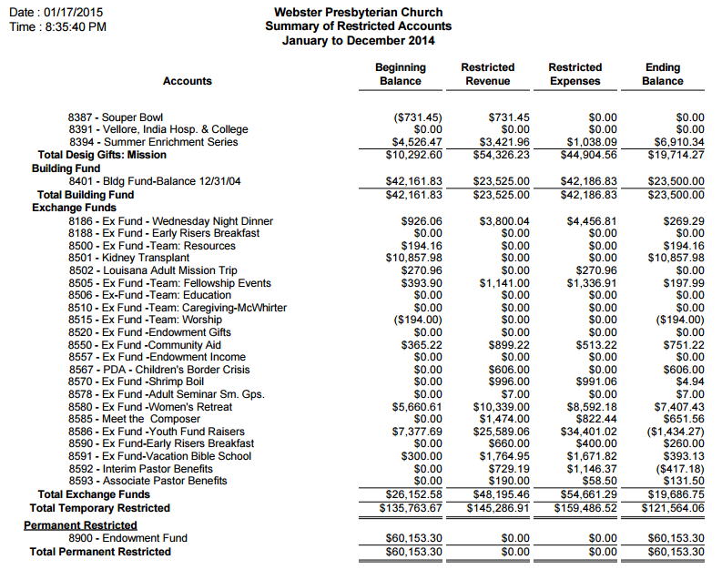

8586 showed a negative balance of $1,434.27 at the end of the year. The error was not caught until the year had been closed.

The cause of the error appears to be expenses that were charged to the account but were supposed to have (ultimately) been charged to other accounts.

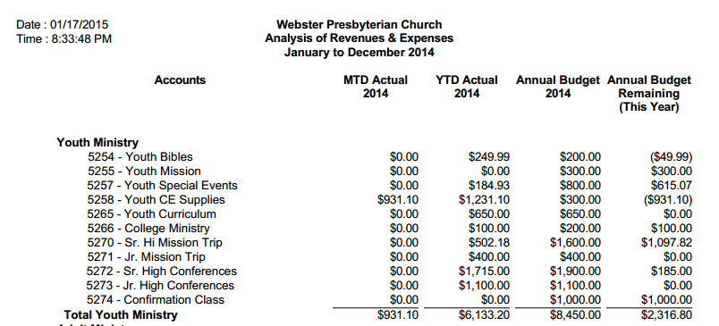

Thus, as can be seen, we had a positive balance at the end of the year due to an improper allocation of expenses to our exchange fund.

Removing the $1000 shown as remaining from 5274 (confirmation class), we are left with an unused budget of $1,316.80 which very closely mirrors the negative balance ($ 1,434.27) in our exchange fund. In essence, the Youth budget should have reflected a slight negative budget in operating accounts and a positive balance in our exchange account.

2014 Budget Summary
Operations: $10,464.00
One Big Auction: $15,282.00
Total: $25,746.00

2015 Proposed Summary
Operations: $ 5,365.00 (51.27 % of 2014)
One Big Auction: $ 8,361.79 (54.72% of 2014)
Total: $13, 736.79 (53.36% of 2014)

Lower budget numbers proposed by Stewardship and Finance are based on erroneous numbers from 2014. It looks as if the Youth budget was not completely depleted when in fact it was.

We are certainly willing to do our part, but we cannot serve the youth of Webster Presbyterian Church with a budget that is basically half of the previous year. This is in addition to the financial mistake that hit our exchange fund last year.

