Average Attendance 274 November 2010
Average Attendance 500 November 2011

Background
Outreach is about spreading the message outside of the congregation; to connect our ideas to other groups and the general public.
Outreach team does not initially look inward for making changes, but rather to take what we’ve got just the way it is and spread it out to the community. We will look inward only to study who the congregants are and what programs we have to offer. We will look inward to educate the congregation on the task of asking people they meet to come join us.
The team’s focus will be outside the church. We will target our core demographic as well as the general public.
- Goal is to build the kingdom of God.
- Objective is 500 attendees in the sanctuary.
- The key performance indicator (KPI) will be an attendance average of 500 per Sunday (total of both services combined) for representative month, November, 2011.
- The vision is to let people know WPC is here, it’s open and welcoming, and they are invited!
- To encounter the loving god, to nurture followers of Jesus Christ, and to meet human needs.

Five-Step Marketing Plan
- Unique selling proposition (sets us out from the rest)
- Target market
- Benefits of our programs
- Position of our programs
- Marketing methods
Congregation
Advertising
Internet Marketing
Social Media
Direct Marketing
Public Relations
Budget
Educating the congregation (expenses for sample shirts, etc.)
Target market
Survey internal demographic
Survey footprint demographic
Advertising, traditional
Internet marketing
Direct Marketing
Mailers
Outreach Activities (festival booths, canopy, private-label water, t-shirts for participants)
Public Relations (expenses for representative to speak at events)

ACTIONS for Session Tap Session’s Intuition – all parts of session.
Relationship between Outreach and Vision.
Brainstorm step #1 – what is it that sets us apart.
Agree on our target market
Brainstorm benefits of our programs (our Active Parenting class provides an outlet for parents.)
Brainstorm position of our programs (our Sunday School class is smaller/bigger/more fun, etc.)
Update external website – more splash.
Update internal website – org chart and meeting minutes.
Primary Research
Direct Mail Questionnaire (<5% return)
Personal Interviews, Groups/individuals, mail, phone.
Market situation – church corollaries/equivalants to business attributes
· What are our products/services or product/service lines? WPC’s programs
· What is the dollar size of your markets? WPC equivalent is total congregants in area.
· What is your sales and distribution setup? Church equivalent is server-doers working out of one main office.
· What geographic area do you sell to? Quantify the church footprint.
· Describe your audience in terms of population, demographics, income levels and so on. Describe our existing congregation and we will have described our target audience.
· What competitors exist in this marketplace? Other congregations in the area.
· Historically, how well have your products sold? Describe historical success. (Sulzer Intermedics Angleton example.)

Threats & Opportunities
This section is an extension of the "market situation" section, and it should focus on the bad and good implications of the current market:
· What trends in the marketplace are against you? Johnson Space Center (JSC-NASA) shrinking; secularization; Anomie (fragmentation, disassociation, Gemeinschaft (community) is disappearing); eroding ideology; changing demographics.
· Are there competitive trends that are ominous? Congregations catering to the ‘’God’s plan for you’’ audience; ‘’feel good’’ churches.
· Are your current products poised to succeed in the market as it now exists? We believe so.
· What trends in the marketplace favor you? Growth in League City, West Ranch
· Are there competitive trends working to your benefit? Ask Session attendees.
· Are the demographics of your market in your favor? Against you? League City, Friendswood West Ranch working in our favor. Webster city, Neighborhoods affected by JSC consolidation working against us.

Marketing Objectives – what we want to achieve. That WPC is here, it’s open and welcoming, and they are invited! (Invited to encounter the loving god, to nurture followers of Jesus Christ, and to meet human needs.)
Quantifiable Goal
· Introduce new products Not right now, but example goal for 3-5 years (mid-term) would be to develop a 20-30 y.o. singles group, then, yes, to introduce that new service to the market.
· Extend or regain market for existing product This is it.
· Enter new territories for the company This applies to League City.
· Boost sales in a particular product, market or price range. Specifically, where will this business come from? Heighten awareness in existing market (JSC-NASA/Webster/Clr. Lk.), expand into target market (League City, West Ranch.)
· Cross-sell (or bundle) one product with another Social networking bundled with meeting spiritual needs. Fun, food, fellowship with encountering the loving God, etc.
· Enter into long-term contracts with desirable clients Singles done with the bar-scene, young marrieds, young families.
· Raise prices without cutting into sales figures Not applicable.
· Refine a product Mid-term goal.
· Enhance manufacturing/product delivery Longer-term goal.

Budget
Control – Track Effectiveness

Special Events to raise awareness, Promotional Events
- Lent/Vacation Bible School/Christmas direct mailings.
- Summer festivals in Clear Lake, Friendswood (7/4), League City, Dickinson, etc.
- Lunar Communion July
- Dennis Dewey event, October 28, 29, 30.
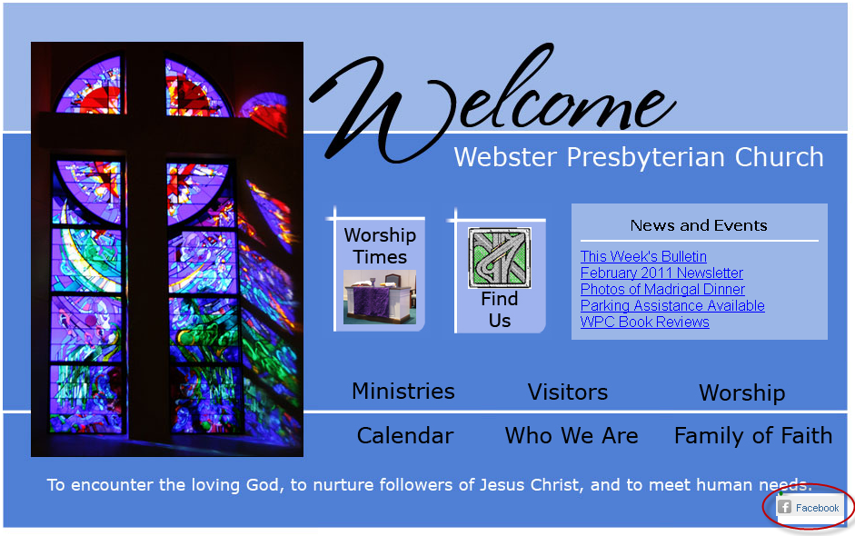
Facebook’s “Like” Button on Website

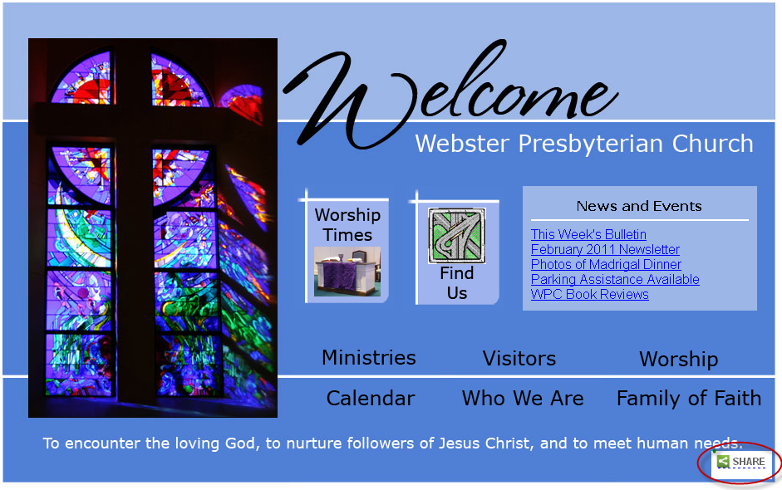
Requested Adding Social Networking Feature

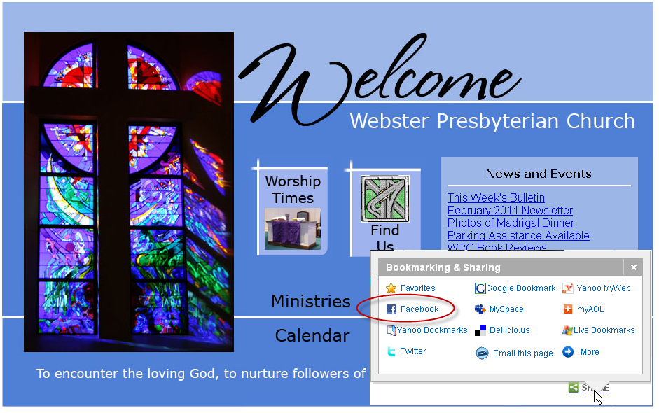
Facebook’s “Like” Button along with other social networking sites.

