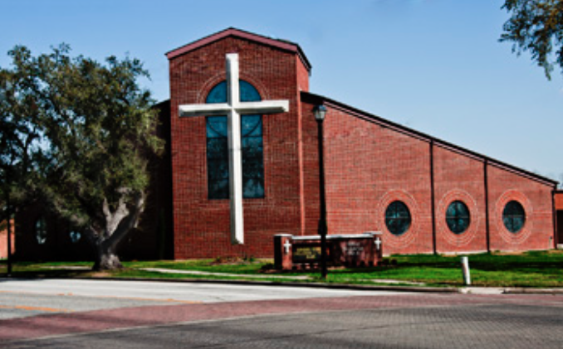
WEBSTER, TX
FEBRUARY 3, 2016
WEBSTER PRESBYTERIAN CHURCH

FACILITY ENERGY ASSESSMENT AND RECOMMENDATIONS:
512.971.2364
2410 GREAT OAKS DR #103
Round Rock, TX 78681
PREPARED BY:
LIT CONSULTING, LLC
COLBY MAY, CEM.

Table of Contents
1.0 EXECUTIVE SUMMARY: 3
2.0 ENERGY ASSESSMENT PROCEDURE: 5
3.0 ENERGY PERFORMANCE INDICATORS: 6
4.0 ENERGY MANAGEMENT GOALS: 11
5.0 ENERGY RECOMMENDATIONS: 12
ECRM #1: SCHEDULING OPPORTUNITIES 12
ECRM #2: PURCHASE WIFI-ENABLED COMMERCIAL THERMOSTATS. 15
ECRM #3: DOMESTIC HOTWATER. 16
ECRM #4: COMB COILS 16
ECRM #5: HVAC INSULATION 17
ECRM #6: REPLACE HVAC UNITS 17
ECRM #7: VARIABLE FREQUENCY DRIVES 18
ECRM #8: OUTSIDE AIR 18
ECRM #9: LIGHTING RETROFIT: 18
ECRM #10: LIGHTING BEHAVIOR OPPORTUNITIES: 19
ECRM #11: WEATHERSTRIPPING: 20
ECRM #12: WINDOWS: 21
ECRM #13: SOLAR 22
ECRM #14: ELECTRICAL PANELS 22
ECRM #15: PLUG LOAD ADAPTERS OR SMART STRIPS 23
ECRM #16: BATHROOM EXHUAST 23
ECRM #17: LOW FLOW AERATORS. 23
ECRM #18: NACFM 24
6.0 MAINTENANCE & OPERATION RECOMMENDATIONS: 25
7.0 FINANCIAL OPTIONS: 28
8.0 MISSION/JUSTICE 30
9.0 SOLAR 32
10.0 GENERAL COMMENTS 32

1.0 EXECUTIVE SUMMARY:
This ASHRAE LEVEL 2 ENERGY AUDIT is provided to Webster Presbyterian Church (hereafter known as WPC) in Partnership with LIT Consulting (hereafter known as LIT). This energy report was done in partnership with the Presbyterian Foundation and the New Covenant Presbytery.
The service assists churches and institutions to take basic steps towards energy efficient facility operation and environmental sustainability. Active involvement in the partnership from the entire administration and staff within the agencies and institutions is critical in developing a customized blueprint for energy efficiency for their facilities.
In February 2016, LIT was retained by WPC, for the performance of an ASHRAE Level 2 Energy This report is intended to provide support for the church as it determines the most appropriate path for facility energy practices and renovation, especially as it pertains to the energy consuming systems around the facility. It is our opinion that decreases in annual energy costs, as well as major maintenance cost reductions, can be achieved through the efficiency recommendations provided herein. The main focus of the report will focus on assisting the church in building upon their existing energy management program that will address maintenance and operation recommendations.
This study has focused on energy efficiency, behavior and systems operations. To that end, an analysis of the utility usage and costs for WPC was completed by LIT to determine the annual energy cost index (ECI) and energy use index (EUI) for the facility. A complete listing of the Base Year Utility Costs and Consumption is provided in Section 3.0 of this report.
Following the utility analysis and a preliminary consultation with the facility team a walk-through energy analysis was conducted throughout the campus. Specific findings of this survey and the resulting recommendations for both operation and maintenance procedures and cost-effective energy retrofit installations are identified in Section 5.0 of this report.
We estimate that as much as $12,864 (38.02% savings) may be saved annually if all recommended projects are implemented. The estimated installed cost of these projects should total approximately $182,155 yielding an average simple payback of 14.16 Years. These numbers do not take into effect maintenance savings or rebates.
We would like to thank the WPC team for their support during the site survey, and the valuable explanations of existing equipment and operations. We appreciate the fact that the church staff went above and beyond in assisting us in the energy audit. Their knowledge of the systems is extensive, and the findings/recommendations herein would not have been possible without their assistance.

ECRM | PROJECT | COST | SAVINGS | PAYBACK (Years)
1 & 2 | Zoning & WIFI Stats | $8,100 | $2,500 | 3.2
3 | Domestic Hotwater | $250 | $125 | 2.0
5 | HVAC Insulation | $200 | $100.00 | 2.0
6 | HVAC Replacements | $140,000 | $5,600 | 25.0
7 | VFD's | $5,000 | $715 | 7.0
9 | Lighting Retrofit | $27,005 | $2,700 | 10.0
10 | Lighting Behavior | $0 | $650 | 0.0
11 | Weather-stripping | $250 | $50 | 5.0
12 | Windows | $1,000 | $200 | 5.0
15 | Plug Load Adaptors | $250 | $125 | 2.0
17 | Aerators | $100 | $100 | 1.0
TOTAL |  | $182,155 | $12,865 | 14.16
Total Energy Cost |  | $33,840
Total Project Savings |  |  |  | $12,865
% Savings |  |  |  | 38.02%

38% energy savings is high, however we believe we are missing gas bills which will adjust the savings and payback. The HVAC savings have been stretched out over 20+ years given the added electric load at the library. The Lighting payback has been stretched out over 10 years given low burn hours.

Table 1: Summary of Recommended Energy Cost Reduction Measures (ECRMs)

NOTE: CENTERPOINT OFFERS ENERGY EFFICIENT REBATES THAT COULD OFF-SET THE COSTS OF HVAC & LIGHTING INVESTMENTS BY UP TO 20%.

These savings only account for ENERGY cost and do not include maintenance or water savings. Also these projects only account for the immediate capital expense projects. Low Cost recommendations mentioned in the report could increase savings. Our final “summary” comment is that LIT views the completion and presentation of this report as a beginning, rather than an end, of our relationship with WPC. We hope to be ongoing partners in assisting you to implement the recommendations listed in this report. Please call us if you have further questions or comments regarding your Energy Management Issues

*LIT Consulting, LLC. Colby May, CEM (512) 971-2364 colby@consultlit.com

2.0 ENERGY ASSESSMENT PROCEDURE:
This analysis serves as the springboard to form a "partnership" between the client and the consultant for the purposes of energy costs and consumption reduction within owned and operated facilities. An initial visit was conducted by LIT to review the program elements and to select the elements, which could best benefit the church. A summary of the WPC’s most recent twelve months of utility bills was provided to the consultant for the assessment of the Energy Performance Indicators.
Key components of future analyses should include:
- Designing and monitoring customized procedures to control the run times of energy consuming systems.
- Analyze systems for code and standard compliance in areas such as cooling system refrigerants used, outside air quantity, and lighting illumination levels.
- Develop an accurate definition of system and equipment replacement projects along with installation cost estimates, estimated energy and cost savings and analyses for each recommended project.
- Develop a prioritized schedule for replacement projects.
- Developing and drafting an overall Energy Management Policy.
- Assist in the development of guidelines for efficiency levels of future equipment purchases.

3.0 ENERGY PERFORMANCE INDICATORS:
In order to easily assess WPC energy utilization and current level of efficiency, there are two key "Energy Performance Indicators" calculated within this report.

1. Energy Utilization Index
The Energy Utilization Index (EUI) depicts the total annual energy consumption per square foot of building space, and is expressed in "British Thermal Units" (BTUs).
To calculate the EUI, the consumption of electricity and gas are first converted to equivalent BTU consumption via the following formulas:
ELECTRICITY Usage
[Total KWH /yr] x [3413 BTUs/KWH] = __________ BTUs / yr
NATURAL GAS Usage
[Total CCF/yr] x [1,030,000 BTUs/CCF] = ________ BTUs / yr
After adding the BTU consumption of each fuel, the total BTUs are then divided
by the building area.
EUI = [Electricity BTUs + Gas BTUs] divided by [Total square feet]
2. Energy Cost Index
The Energy Cost Index (ECI) depicts the total annual energy cost per square foot of building space.
To calculate the ECI, the annual costs of electricity and gas are totaled and divided by the total square footage of the facility:
ECI = [Electricity Cost + Gas Cost] divided by [Total square feet]
These indicators may be used to compare the facility's current cost and usage to past years, or to other similar facilities in the area. Although the comparisons will not provide specific reasons for unusual operation, they serve as indicators that problems may exist within the energy consuming systems.

GENERAL COMMENTS:

While viewing these Base Year tabulations, a few items stood out as being out of the ordinary and we address them at this point for your consideration:

- Sales Tax – during our review of the bills, we were not able to view an itemized electric bill in order to check costs. Typical miscalculations we find are sales tax, as church are considered non profit and do not need to pay sales tax. We encourage church staff to review 24 months of actual electric and gas bills.

- Peak Demand, WPC’s rate schedule includes both actual demand and billing (ratchet) demand. Basically meaning the church is charged for the amount of kW they use for the particular month, and a separate charge for the peak or highest kW for the year previous year. Ratchet demand is actually 80% of the highest demand the previous year. Again the electric bills were not detailed; as a result we cannot calculate respective kW costs. Peak Demand costs in the spreadsheet above are estimated. Below are definitions for different types of kW.
  - Billing Demand – highest kW (the highest 15 minute period) for the month
  - Ratchet Demand – 80% of the highest kW for the last 12 months. WPC will be billed the ratchet for entire year.
  - 4CP – The average peak kW during 4 hottest months (June-September), typically Monday –Friday between the hours of 2-5.
  - Managing your demand is important. One impact could impact the facility for the entire year. Lowering your peak kW during summer months will not only impact the summer months, but the entire year.

- We were unable to confirm on utility bills, but it is possible the church has a small irrigation area, but only 1 master-water meter. This means the church could be paying sewage (which is 60+% of the water bill) in a non-sewage area. We would encourage further investigation.

- Peak Demand – The electric kW for the church peaks in July, this is typical given the hot weather and electric cooling. The summer months are also very high; this effects the 4CP portion of the bill. 4CP demand is the average kW for the 4 summer months (June-September). It is possible the church pays this amount the entire year. Lowering kW use during summer months impacts the entire year.
  - The church also has a very large kW during January and February. The church is a combination gas and electric heat, and January and February could be busy holiday periods for the church however we believe WPC can make a significant impact on kW use. We highlight kW reduction opportunities in ECRM 1.

- During our analysis of the Utility Website, we see the church did not leverage the alarm/alert mode. This alarm mode allows the church to set kW and kWh limits, when the building is beginning reaching a kW limit the email will alert the staff. If the staff had a demand response program they could begin implement as a means to lower kW.

- Average Load Factor – By definition Load factor, in essence, means efficiency. It is the ratio of actual kilowatt-hours used in a given period, divided by the total possible kilowatt -hours that could have been used in the same period, at the peak kW level established by the customer during the billing period.

A high load factor is typically “a good thing,” and a low load factor is typically a “bad thing.” A low load factor typically means that you are using electricity inefficiently relative to what you could be if you were controlling your peak demand. http://energysentry.com/newsletters/load-factor-calculations.php

Load factor is calculated using a few simple numbers from the electric bill. The information required is:
- Actual kilowatt-hours used during the billing period, in kwh:
- The Peak kilowatt demand, in kW:
- The number of days in the month x 24 hours

Peak Demand - It is worth noting that all of Electric meters are charged Peak Demand. Peak Demand is the highest 15-minute period during the month, and the church is charged on that highest peak period. Typically peak periods are weekdays, 2pm-5pm, June through September.

Load Factor calculations show that WPC averages 23%. Which is an indicator that lower utility costs could be achieved by reducing peak demand. The church is certainly not in bad shape, however the ratio shows there is opportunity for improvement. As a result, we are recommending several peak demand reducing measures in this report, for example being very conscious of how the church uses electricity between the hours of 1pm and 5pm.
- The Load Factors August – December 2015 are very low, meaning the church uses kW inefficiently in comparison to kWh.

4.0 ENERGY MANAGEMENT GOALS:

A typical building energy use model is broken down as follows:
- HVAC = 50% (as high as 67% in humid areas) of building electric use.
- Lighting = 30% of building electric use.
- Plug Load = 20% of building electric use.

There are different influencers that can affect energy use:
- Building Envelope – Ceiling insulation, windows, roof, doors and more.
- Thermostats – How does a facility control the HVAC?
- Building Occupants – The higher the number of occupants the higher the energy use.
- Weather – Cooling Degree Days or Heating Degree Days
- Behavior – The way we operate lighting, HVAC, building envelope and more.
Our goal is to maintain occupant comfort as much as possible while minimizing usage and reducing cost during unoccupied hours. We highly recommend the church begin to establish energy reduction goals and to benchmark energy use. Benchmarking your energy use on a monthly basis allows you to compare current use with historical use. An excellent and free program (already funded through tax dollars) is EPA’s Portfolio Manager. Portfolio Manager will allow the facility to benchmark all energy use per account per month, which will then allow the church to set and establish energy reduction goals.

5.0 ENERGY RECOMMENDATIONS:

Recommendations:
Although energy cost savings for individual buildings is an important part of these reports, the more important goal is to discover and report on savings opportunities that can be duplicated around the church. Our energy recommendations are separated into 6 different sections:
- CONTROLS
- HVAC
- LIGHTING
- PLUG LOAD
- BUILDING ENVELOPE
- WATER
- BEHAVIOR
As you read through the report, please look at all recommendations carefully, as HVAC and Lighting are typically capital expense projects. The low cost or no cost items are addressed in this section as well as the Maintenance and Operations Section.
We understand the church does not necessarily want to pursue all capital expense projects, however as a part of the audit scope we have included all items for the church to consider for future budgeting purposes. Also keep in mind that many of these recommendations have rebates and incentives offered through your utility company.
Control Opportunities:

ECRM #1: SCHEDULING OPPORTUNITIES
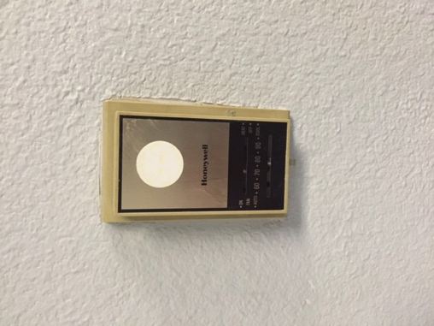
During the audit we identified a number of control strategies that WPC could benefit from. According to the EPA 30% of the energy we use is wasted, which means the energy waste can be recaptured through no cost behavior change. WPC has done a good job managing heir energy use. However we believe we have identified a number of opportunities that will make a strong impact on their kWh and kW savings.
No Cost Opportunities.
- Leverage Zone capability – The church has 18 HVAC zones located throughout the buildings; this is an excellent design to have as it allows the building to zone based on occupancy. We highly recommend taking advantage of this system at all times. For example, if the church only occupies zone 1-2 from 8am-3pm, yet zones 3-4 are unoccupied, we would highly recommend keeping zones off or in setback mode. We did identify a few immediate recommendations:
  - The thermostat that controls two pastoral offices was locked on at 76° during on unoccupied periods. Recommend setting back to 50° during unoccupied periods.
  - The thermostat serving the gallery was locked on 68° yet unoccupied. Recommend setting back to 50°.
  - The thermostat serving the main office was locked on at 72°. It was stated during audit that the thermostat is prone to user error. As a result stay on 24/7 at times.
  - Bounton Hall thermostats were scheduled to come on Monday –Friday from 6am to 10pm at heating and cooling occupied set points of 70° and 78° respectively. The temperature set points are excellent however the occupied operating hours seem very long. If the hall is only occupied Monday – Wednesday 8a-1pm, and Thursday- Sunday from 1pm-8pm, then the thermostat schedule should match occupied hours, and be off or in setback mode all other times.
  - Thermostat servings second floor classroom was locked at 68° heating 24/7. Even Houston gets cold during winter months. We highly recommend keeping heat off during unoccupied periods and only on during occupied periods (only Sunday morning).
  - Both thermostats serving Fellowship hall was locked at 70° 24/7. This calls the heating units and air handlers (both electric) to come on in order to maintain 70°. We highly recommend turning unit off during all unoccupied times.
  - The thermostat serving the main sanctuary was locked on at 69°. This calls for the large 40-ton units to come on in order to maintain the setpoint all 7 days of the week. This is an extremely expensive practice given the large size of the units and given the fact they are all electric.
    - Keep units off during all unoccupied times.
    - Definitely keep 40-ton units off during the hours of Monday-Friday, 2pm-5pm, June – September, since peak demand is set during those times.
    - Managing these large units wisely will make a large impact on Utility expense.
    - The entire Sanctuary Building was running yet unoccupied.
  - A second Sanctuary thermostat was on at 71° and like the above calls for the 40-ton electric units to come on in order to maintain the temperature.
  - Thermostat #3 in sanctuary hallway was locked at 70° conditioning all the classrooms, which were all unoccupied.
  - Thermostat #4 in sanctuary classroom was locked at 68°, which calls units to operate 24/7 in order to maintain temperature.
- Schedule – If the staff is in the building from 8a-5p, the HVAC schedule should hug this schedule as much as possible during cooling seasons.
- Heating Setpoint – We recommend keeping unoccupied heating setpoint to off or 50°.
- We also recommend the facility adjust their occupied baseline temperatures during their Sunday schedules. For every degree adjusted the facility will save 1.5% on the HVAC portion of their bills. An average setback temperature from 69° to 72° can save up to 4.5%
- Sunday Zones –It is possible, but not confirmed, that the church turns on more zones then occupied during Sunday mornings. We understand Sunday is a sensitive day and the church needs to be prepared, however if possible we recommend the church keep unoccupied zones off or in setback mode as much as possible.
- Sunday Temperature – It was stated during walkthrough, that during cooling months the church sets cooling temperature from 65- 69°. This is an expensive practice. If possible, we recommend adjusting Sunday occupied cooling setpoint to 72° or higher. As stated above, for every degree adjusted the church will save up to 1.5% on the HVAC portion of their utility bills.
- Sunday Schedule – The cooling/heating is called to come one at 7am and off at 3pm on all zones. We recommend all zones off at 1 or 2pm based on occupied hours. A centralized thermostat control system (referenced in ECRM 2) will all the church excellent control to manage all zones from one computer location.
- Leverage Holiday Schedule – We noticed the existing controls were not leveraging holiday schedules, which means the HVAC runs on normal schedule on days the church is unoccupied.
- Dead band – In a few of the thermostats the auto setting was on and the temperature difference between heating and cooling set points (also called Delta T) were at 2 degrees. If the heating setpoint is 68° and cooling setpoint is at 70°, the systems would begin to fight with each other as they try to find desired setpoint (simultaneous heating and cooling). We recommend a Delta T of at least 5°, or schedule thermostat to heating only or cooling only mode.
- Tighten startup times – Many of the units start-up at 5:00am Monday-Sunday. The facility staff understands the building needs better then most, however if possible we recommend delaying start up times as much as possible. Consider delaying by 30 minutes to one hour in each zone if possible and off as soon as possible.
- Minimize electric heating and cooling during peak hours. Minimize use of electric equipment i.e., lighting, electric domestic hot water tanks, and any other large electrical users.
- We were unable to verify the cooling temperature set points in many locations. As a rule of thumb we highly recommend leveraging aggressive zone scheduling to match occupied periods.
  - Cooling Occupied Set point = 74-78°
  - Cooling Unoccupied Set Point = Off or 90°
  - Heating Occupied Set point = 66-70°
  - Heating Unoccupied Set point – Off or 50°.
  - Zones = Off or in setback when unoccupied, and on only when occupied. If Zones 1-3 are occupied, yet Zones 4-6 are unoccupied the temperatures should match schedule.
  - Outside Air – Per ASHRAE standard buildings must have outside are coming into the building when building is occupied, however when unoccupied or in minimum occupancy the outside air should be closed. Given the humid conditions in Houston, dehumidifying outside air is expensive. We recommend staff checking outside air dampers on the air handlers.
- Please see http://energy.gov/energysaver/articles/thermostats for EPA recommendations regarding setback, scheduling, zoning and more.
Estimated Cost zero, Savings will be partnered with ECRM 2

ECRM #2: PURCHASE WIFI-ENABLED COMMERCIAL THERMOSTATS.
During the assessment we noticed the church has 18 thermostats (although we could not identify all locations) that controlled 18 separate zones. These thermostats offer excellent opportunity for the church to be aggressive with energy management as referenced in ECRM #1. The existing thermostats are not WIFI-enabled and decentralized, which could result in many stats being locked at 68-70° during unoccupied period. Given the manual scheduling the thermostats are still prone to user error, as was identified during assessment. As a result, we highly recommend replacing all 18 thermostats with WIFI-enabled stats and leveraging the thermostat software program to consolidate and centralize scheduling. This will allow the church to schedule thermostat holidays, set points, zoning and more from one centralized location, which minimizes user-error. Thermostats cost around $400 installed.
Options:
- www.yourcomfortwindow.com (portion of sales go to Holistic Missions).
- Nest Thermostats https://nest.com

Estimated Cost: $8,100 Estimated Savings:HVACsavings $2,500 Estimated Payback: 3.2 years
- These savings have been partnered with ECRM #1.

ECRM #3: DOMESTIC HOTWATER.
We found 3 electric domestic hot water tanks that provide hot water to numerous bathrooms and the kitchen. The unit is in good condition; however there are a few recommendations we would like to make that will increase the efficiency of the respective units.
- Add piping insulation – Most of the heat is lost through the pipes. Adding pipe insulation will not only retain the heat, but also allow the return water temperature to remain constant, thus allowing the tank to work less. We recommend 50 feet of pipe insulation to accommodate the unit in the boiler room located in the basement
- Reduce temperature – Many churches set temperatures at 140°, however per code that maximum recommended temperature is 120°. We recommend setting temperature at 110° and increase the heat as needed.
- Add Timeclock – The current tanks currently heat the water 24 hours a day in order to maintain the 120° temperature. We recommend adding time clocks to the tanks that would allow the unit to turn off during unoccupied hours of 10pm-7am. This will make a big impact on energy reduction for the units.
- Peak Demand – As stated peak demand is the amount of kW used during the hours of 2pm-5pm. Given the fact the unit is a 5.5 kW unit, keeping the unit off during peak hours (via time clock) will benefit the church in both kWh and kW savings.
Estimated Cost: $250 {FILLINHVACcost Estimated Savings:HVACsavings $125 Estimated Payback: 2 Year

HVAC:

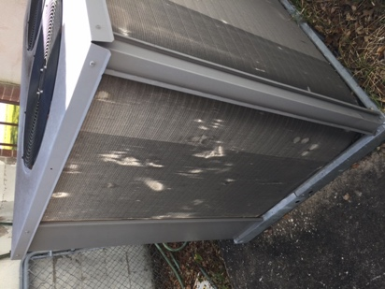
ECRM #4: COMB COILS
During the assessment we found that most Rooftop Units on roof had bent in or damaged coils. If a coil is damaged by as little as 10% the unit can lose up to 30% of the efficiency of the unit. We recommend having the facility manager purchase an HVAC fin-comb in order to comb back the coils and regain the efficiency. On all future units we highly recommend purchasing hail guards. This act will increase the efficiency of the units, increase the life and save energy.

ECRM #5: HVAC INSULATION
Most of the refrigerant lines serving all exterior HVAC equipment were missing or damaged. Most of refrigerant line temperature is lost at the piping. A lack of insulation can compromise the refrigerant temperature, thus cause the unit to work longer and harder then needed in order to reach setpoint. We highly recommend upgrading insulation as soon as possible.
Estimated Cost: $200{FILLINHVACcost Estimated Savings: $100 Estimated Payback: 2 years

ECRM #6: REPLACE HVAC UNITS
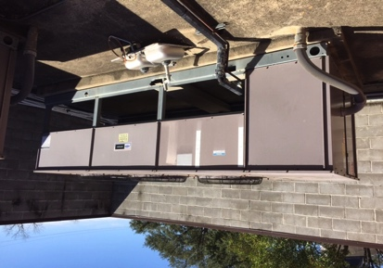
The church is conditioned with a number of rooftop and split systems. Most of the units are newer and in good shape, although there is significant coil damage and missing refrigerant insulation. The 40-ton split systems serving the sanctuary are only 13 years old, however the coils are badly damaged due to salt-water corrosion and maintenance neglect. Given the age of the units, and given the cost to replace coils (typically half the cost of a new unit) we would recommend replacing the two existing 40-ton units (electric heat) with four new 20-ton 13 SEER packaged units with gas heat or 13 SEER electric heat pumps. The costs range from $1,300-$1,700 per ton based on the unit type.
We also recommend replacing the two 5-ton units serving the ED Building with new 17 SEER Heat Pumps. The Library Unit is currently not working, and does not draw an electric load, thus the overall savings for the project will be skewed due to added load.
Estimated Cost: $140,000{FILLINHVACcost Estimated Savings: $5,600 Estimated Payback: 25 years
Centerpoint Energy offers excellent rebates, via their SCORE Light Program for Churches, for new HVAC equipment that could offset the cost of the projects by 10% or $14,000.

ECRM #7: VARIABLE FREQUENCY DRIVES
Air handlers #3 and 4 serving the sanctuary have 10 horsepower motors that provide conditioned air to respective zones. However the motors are constant volume, which means regardless of demand the motors run at 100% capacity or constant volume. We recommend installing Variable Frequency Drives on AHU 3 and 4 in order to vary motor speed based on demand.
Estimated Cost: $5,000{FILLINHVACcost Estimated Savings: $715 Estimated Payback: 7 years

ECRM #8: OUTSIDE AIR
In many cases the outside air units serving the air handlers were locked open. Per code, HVAC units larger then 2.5 tons require a certain amount of outside air when the building is occupied, this prevents Indoor Air Quality. However when the building is unoccupied the outside air units should be in a minimum position (5% open). Houston is a very humid climate, and Webster is less then 5 miles from the ocean. When outside dampers are left open this allows humid air into the building HVAC system. This humid outside air is dehumidified (cooled to 32°) in order to wring the humidity out of the air and than reheated (electric strip heat) to the respective rooms. We highly recommend checking damper positions, and keep outside air dampers locked in a minimum position 5% during unoccupied times.
Lighting:

ECRM #9: LIGHTING RETROFIT:
During our assessment we noticed numerous 40-watt T-12 Linear Fluorescents through out the church. The 40-Watt T-12’s is being faced out, and is no longer manufactured. We highly recommend the church consider replacing the lamps with 13-watt or 16-watt LED linear Fluorescents. Replacing all 3 or 4-lamp with 2-lamp 13-watt LED Linear Fluorescents or equivalent will make a large impact on energy use. This is a drop from over 160-watts per fixture to around 26-watts. In the past LED Lamps were not at quality regarding color-rendering index (too white/bright) or to the ambient, however with the advances in technology and costs current LED Linear Fluorescents have surpassed quality control tests. Many engineering and consulting firms, including our firm, now recommend LED’s as a first priority replacement. Should the church not want to invest in an entire campus retrofit, we would recommend renovating a few offices and common areas first to ensure quality. LED’s lamps use up to 80% less energy and last 5 times as long when compared to existing lamps.
Fellowship Hall: We noticed a number of 150w halogens in the Fellowship Hall, we recommend replacing all bulbs with Par 38- LED’s.
Exits: We also noticed a number of 50-watt incandescents exit lamps; we recommend replacing with 5-watt LED inserts.
Sanctuary Lighting: The lighting serving the sanctuary is comprised of a combination of 500-Watt Metal halides, 100-Watt Metal Halides and 32-watt T8 linear fluorescents. We recommend replacing each with LED equivalents per the inventory below. The payback has been stretched out due to low burn time.
Switch: Should the church move forward with this recommendation, we would recommend dual switch fixtures in all rooms. This will allow the church to turn on lights in zones, opposed to 100% on or off.
Centerpoint Energy offers excellent and lighting rebates via their SCORE Lite program (for churches) that could amount to 20% of light cost or $5,400.

ECRM #10: LIGHTING BEHAVIOR OPPORTUNITIES:
There are a number of opportunities for WPC to reduce lighting load through no cost behavior change. The same rule that applies to HVAC applies for lighting. Lighting makes up 20-30% of a building electrical load. A 10% reduction in lighting can impact the electric bill by 2-3%.
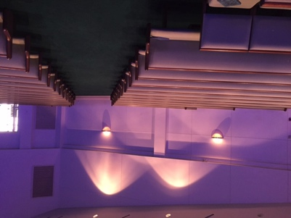
- Delamping – There were 96 4-lamp T-2 lights that provide more task level light than needed. We recommend delamping all lights from 4-lamp to 3-lamp or 2-lamp if possible (delamp 2 center bulbs). This will reduce light electric load by 25+% while maintaining quality task level lighting. The maintenance staff could de-lamp a certain room or hallway to test light level before de-lamping entire facility.
- Uplighting – The lights shining up (five 60watt incandescents) offer no task level lighting, and from an energy management point of view are not recommended. We recommend keeping lights off. However if the church wants to keep lights for aesthetic look, we would recommend replacing incandescents with 8-Watt LED ($8 per bulb).
- Daylighting – There are a number of opportunities to optimize daylighting. There were fixtures on by large windows that made no impact on task level lighting. We highly recommend keeping these fixtures off, placing them on their own light switch or adding them to a photocell.
- Behavior – Based on the number of lights left on in unoccupied rooms we would recommend implementing a behavior-program for all staff. This would encourage all employees to turn off lights if gone longer than 23 seconds. Another option could be to install motion sensors, however this defeats the purpose of teaching staff. Promoting behavior practices at the office, such as turning off lights, allows staff to take the information/practices to their homes.
Estimated Cost: 0 {FILLINHVACcostEstimated Savings:HVACsavings $650 Estimated Payback: Instant
Building Envelope:

ECRM #11: WEATHERSTRIPPING:
During our assessment we noticed numerous doors, and windows that lack sufficient weather-stripping or insulation. As you will see in these thermal imaging photos, the strength of the building envelope is compromised when insulation and/or weather-stripping is lacking. This causes the HVAC to work longer then needed in order to maintain se point temperature. We highly recommend strengthening all windows and doors.
- Fellowship Hall Door, shows gap.
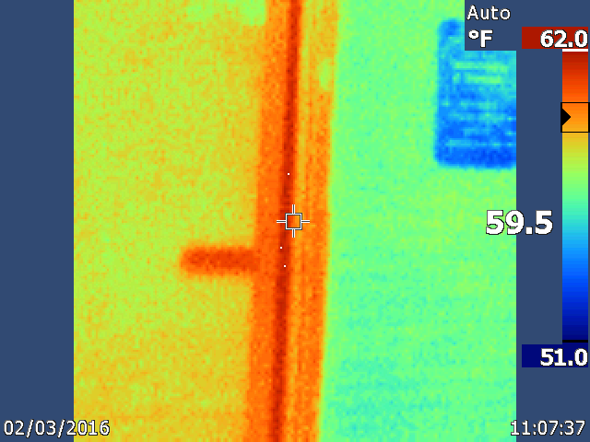
- Metal Door East Side of New Sanctuary.
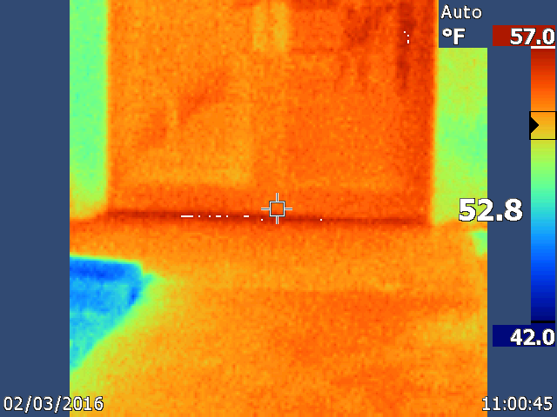
- NASA Side entrance of ED Building (Gap under door)
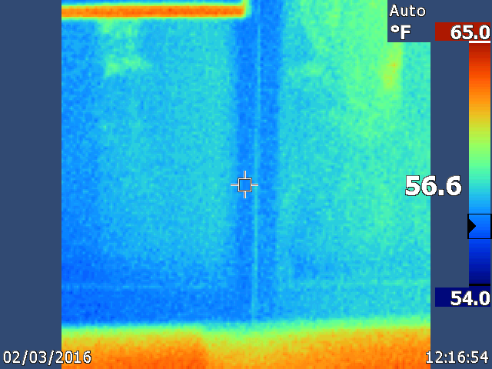
- Bouton Entrance, NASA Side, Above Double Doors.
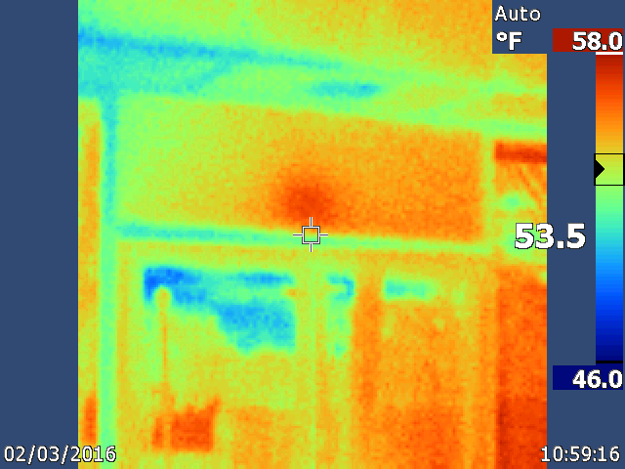
- Stain-Glass Windows on NASA-Side of ED Building.
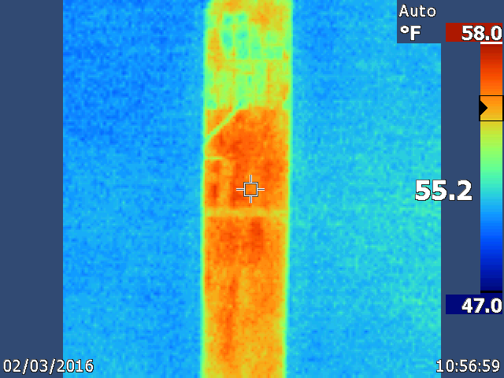
Estimated Cost: $250 {FILLINHVACcostEstimated Savings:HVACsavings $50 Estimated Payback: 5 Years

ECRM #12: WINDOWS:
There are two large single-pane windows that serve the two pastoral offices. The windows compromise the respective offices and as a result are either too hot or cold based on the season. This causes the HVAC to run more then needed in order to satisfy the respective areas. This also affects the other offices, since the entire office area is on a single HVAC zone. We recommend replacing both office windows with dual-pane thermal coated windows.
Estimated Cost: $1,000 {FILLINHVACcostEstimated Savings:HVACsavings $200 Estimated Payback: 5 Years
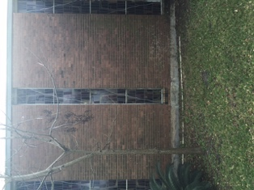
- We would also recommend adding storm windows to many of the other single-pane windows. We performed a study at Harvard and measured the temperature difference between a single and single-pane with window storm and found a Delta T (temperature difference) of 6 degrees.
- Above cost only cost for Window replacement in the two offices.

RENEWABLE ENERGY & PREVENTIVE MAINTENANCE:

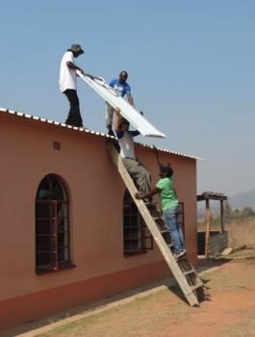
ECRM #13: SOLAR
We believe the church would be a prime candidate for Solar given their building layout. Should the church have interest, we have partnered with Iluminate L3C in order to provide solar to churches as a means to empower missions. Most of the church installations we have performed have had a payback of 5-7 years; a big reason for this is the Tax Credit that is past back to the church as a means to lower overall cost of installation. Please contact Colby@cosultlit.com if interested in more information.

ECRM #14: ELECTRICAL PANELS
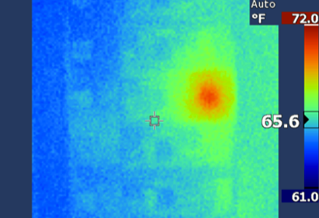
During the assessment of the mechanical and electrical rooms we took thermal imaging pictures of many electrical panels. We noticed many of the breakers were hot, which suggest loose lugs. We have identified the loose connections and associated pictures. The list is not comprehensive, as not all electrical panels were assessed. These loose connections create a fire hazard; as a result we highly recommend addressing the loose connections with a certified electrician as soon as possible.
- Electrical Panel FACP in Ed Builing, (Cleaning Supply Closet), fuse 23 and 22 are loose.
- Electrical Panel PA, Breakers 12 and 27 are loose in Fellowship Hall.

PLUG LOAD:

ECRM #15: PLUG LOAD ADAPTERS OR SMART STRIPS
Plug Load makes up about 20% of the church electric use. There are a number of ways to reduce plug and phantom load. Phantom load is the continual use of energy for plug load items (microwave, computers, TV’s) even when the items are turned off. As a matter of fact, 75% of plug load energy is used when an item is off. The church could reduce plug load by buying newer Energy Star rated units, unplugging devices, sleep mode, minimizing use, or by the installation of plug load adapters/smart strips. Plug load adapters cut the use of phantom load after a unit is turned off or no longer in use, opposed to standard adapters which continue to draw energy. We recommend the church pursue a BETA program in the administration building. We recommend the purchase and installation of 5 adapters. The respective office would plug in all or highest consuming plug load items into the plug load adapters. Typical cost is around $50 per adapter.
Estimated Cost: $250{FILLINHVACcost Estimated Savings:HVACsavings $125 Estimated Payback: 2 Years

ECRM #16: BATHROOM EXHUAST
We noticed two exhaust fans were running during our assessment of the roof. This practice not only wastes energy at the motor, but also pumps conditioned air outside. We recommend the church add motion sensors to the bathroom lights and tie the exhaust fans to the motion sensor.
WATER:

ECRM #17: LOW FLOW AERATORS.
During the assessment we documented a number of faucets that lacked 0.5 low flow aerators. We recommend buying, or working with the City to obtain free aerators.
The average flow rate of a kitchen or bathroom faucet is around 2.2 gallons per minute; the aerators will minimize that to 0.5 gpm. = $5 per aerator x 20 = $100. If faucets used an average of 2,200 gallons per month, the new aerator equivalent would be 500 gallons. Keep in mind this affects usage and sewage rates, cutting usage by more than 60%.
20 .5gpm faucet aerators * $5 per aerator = $100 = 1 year payback
Estimated Cost: $100 {FILLINHVACcostEstimated Savings:HVACsavings $100 Estimated Payback: 1 year
EDUCATION:

ECRM #18: NACFM
As a means to provide ongoing education and networking, we would recommend the facility manager or representative join a national association of likeminded individuals as a means to grow in the trade, build relationships, grow in knowledge and more. There are a number of opportunities for education, networking and more. One such example is the National Association of Church Facility Managers or MACFM. More information can be found at www.nacfm.com.

6.0 MAINTENANCE & OPERATION RECOMMENDATIONS:

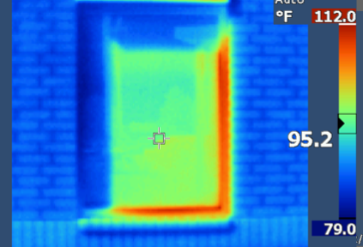
Maintenance and Operation procedures are strategies that can offer significant energy savings potential, yet require little or no capital investment by the church to implement. Exact paybacks are at times difficult to calculate, but are typically always less than one year. The difficulties with payback calculation are often related to the fact that the investigation required to make the payback calculation, for example measuring the air gap between exterior doors and missing or damaged weather-stripping so that exact air losses may be determined, is time and cost prohibitive when the benefits of renovating door and weather weather-stripping are well documented and universally accepted.
HVAC M&O
WPC, there are a few HVAC M&O opportunities that revolve around combing the condenser fins [combs available for less than $10]. The installation of coil guards prevents future fin combing, which is ultimately a combination of deferred labor savings for eliminating the need for maintenance personnel to perform the task and energy savings resulting from the units maintaining optimum operating efficiency. We recommend installing hail guards on the units to prevent future coil fin damage. A system can lose up to 30% of its efficiency if up to 10% of the coils are damaged.

The hot water tanks lack pipe insulation. Much of the heat loss in hot water tanks or boilers are due to uninsulated piping. We recommend WPC address these areas when convenient.

Please be very sensitive when operating electric, electric reheat and electric motors during peak hours (Domestic Hot water Tanks). By minimizing the use during peak (M-F 2-5) will reduce the peak kW, which will affect their utility cost year around. Consider adding time clocks to all Electric Domestic Hot water Heaters, in order for them to remain OFF during peak hours.

It was noted that the domestic hot water tanks in certain parts of the church were above 120°, in kitchen areas water needs to be at 160°.

Lighting M&O

WPC has done an excellent job disengaging lights in the “non public” areas. There were still some areas of the buildings had light fixtures that were not required to be operating during the day or where fixtures left operating in unoccupied spaces. The least expensive remedy to these issues is to train staff to not turn on fixtures not needed during daytime hours and to turn off fixtures in unoccupied spaces. Failure of the behavioral modification training will require the church to invest capital into automatic controls for the fixtures.

The footcandle measurements we took on campus were significantly higher than IESNA recommendation for illuminance.

Type of Activity Lighting Levels Footcandles

Classrooms & General Offices 50 +/- 20%
Specialized Labs, Data Processing 75 +/- 20%
Work areas infrequently used (e.g., storage) 15 +/- 20%
Public Areas (e.g., hallways, etc.) 5 +/- 20%


7.0 FINANCIAL OPTIONS:


8.0 MISSION/JUSTICE
As mentioned the goal of the audit is not only to promote stewardship, but to also free up resources already going to the utility companies with the direct goal of serving the most vulnerable. Should your church realize energy savings as the result of this report, our hope is that you would prayerfully consider supporting the below ministries in some capacity. Our founder was a graduate of Gordon Conwell Seminary with a focus on Integral Missions, and the primary reason for the creating LIT was to serve the most vulnerable in a strategic life changing way. We do this by partnering with united well respective local churches that have been influential in their respective cultures for many years. In order to change the hands we must change the heart, we must be strategic in our response to injustice, we must strike at the roots of the issues with the goal of sustainable change. Holistic meaning physical, spiritual, emotional and economical change led with the whole Gospel of Jesus Christ. Below are partnered organizations that we believe emulate these strategies. Should you have any questions please contact Colby@consultlit.com.

_________________________________________________________________________
1.

VISION
Our vision is to see holistic development {physical, spiritual, social & economic} within communities of India & Nepal through the Whole Gospel of Jesus Christ.
MISSION
Influence International, Inc. exists to train, resource and send individuals to plant churches in the most unreached areas, to strategically respond to the physical, social and economic needs and to equip and mobilize churches and individuals to be missional in nature.
STRATEGY
- Establish Bible Institutes in various states of India and Nepal to equip workers for pioneer ministries
- Plant churches in unreached areas to reach out to communities
- Empower needy children by establishing orphanages and educational centers
- Bring economic stability to deeply impoverished people by giving vocational training and enabling people to establishing micro-businesses in India and Nepal
- Personal development through adult-literacy programs
- Respond to physical and social needs through strategic actions, working alongside local leaders
- Pursuit: Churches, a curriculum created to equip and mobilize churches and individuals to be missional glocally (globally & locally), through seminars.
- Create life-changing opportunities for people in various countries to take part in discipleship trips to India

Influenceintl.org

_____________________________________________________
2. 

OUR CALLING AT WORLD RELIEF IS TO STAND WITH THE VULNERABLE

Every second of every day children are orphaned by disease, women are widowed by conflicts, families are devastated by natural disasters and refugees are relocated to new countries. These are the heartbreaking stories of the vulnerable.

We believe God has equipped the church - the most diverse social network on the planet - to be at the center of these stories, leveraging time, energy and resources to join the vulnerable in their time of need.

We practice principles of transformational development to empower local churches in the United States and around the world so they can serve the vulnerable in their communities. With initiatives in education, health, child development, agriculture, food security, anti-trafficking, immigrant services, micro-enterprise, disaster response and refugee resettlement, we work holistically with the local church to stand for the sick, the widow, the orphan, the alien, the displaced, the devastated, the marginalized, and the disenfranchised.
In our own backyard and around the globe, we stand with individuals and communities through the process of healing, reconciliations, transformation and empowerment.
Whatever it takes, and wherever it takes us, we are faithful to our call.

www.worldrelief.org

9.0 SOLAR
Should the church have interested we have partnered with Iluminate in order to provide solar to churches as a means to empower missions. We leverage grants, rebates, tax incentives and more in order to provide a very low payback. Please contact us at Colby@cosultlit.com if interested in more information.

10.0 GENERAL COMMENTS

This report has been prepared for the exclusive use of our client for specific application to the project discussed and has been prepared in accordance with generally accepted engineering practices. All estimations provided in this report were based upon information provided to LIT by the church and their respective utility providers. While costs saving estimates have been provided, they are not intended to be considered a guarantee of cost savings. No guarantees or warranties, expressed or implied, are intended or made. Changes in energy usage or utility pricing from those provided will impact the overall calculations of estimated savings and could result in different or longer payback periods.

APPENDICES

APPENDIX I - SUMMARY OF FUNDING & PROCUREMENT OPTIONS FOR CAPITAL EXPENSE PROJECTS

SUMMARY OF PROCUREMENT OPTIONS FOR CAPITAL EXPENDITURE PROJECTS
State Purchasing:
The General Services Commission has competitively bid contracts for numerous items, which are available for direct purchase.
Design/Bid/Build (Competitive Bidding):
Plans and specifications are prepared for specific projects and competitive bids are received from installation contractors. This traditional approach provides the church with more control over each aspect of the project, and task items required by the contractors are presented in detail.
Design/Build:
These contracts are usually structured with the engineer and contractor combined under the same contract to the owner. This type team approach was developed for fast-track projects, and to allow the contractor a position in the decision making process. The disadvantage to the church is that the engineer is not totally independent and cannot be completely focused upon the interest of the church. The church has less control over selection of equipment and quality control.
Purchasing Standardization Method:
This method will result in significant dollar savings if integrated into planned facility improvements. For larger purchases, which extend over a period of time, standardized purchasing can produce lower cost per item expense, and can reduce immediate up-front expenditures. This approach includes traditional competitive bidding with pricing structured for present and future phased purchases.
Performance Contracting:
Through this arrangement, an energy service company (ESCO) using in-house or third party financing to implement comprehensive packages of energy saving retrofit projects. Usually a turnkey service, this method includes an initial assessment of energy savings potential, design of the identified projects, purchase and installation of the equipment, and overall project management. The ESCO guarantees that the cost savings generated will, at a minimum, cover the annual payment due over the term of the contract.

EXAMPLE OF AN ENERGY PROGRAM:
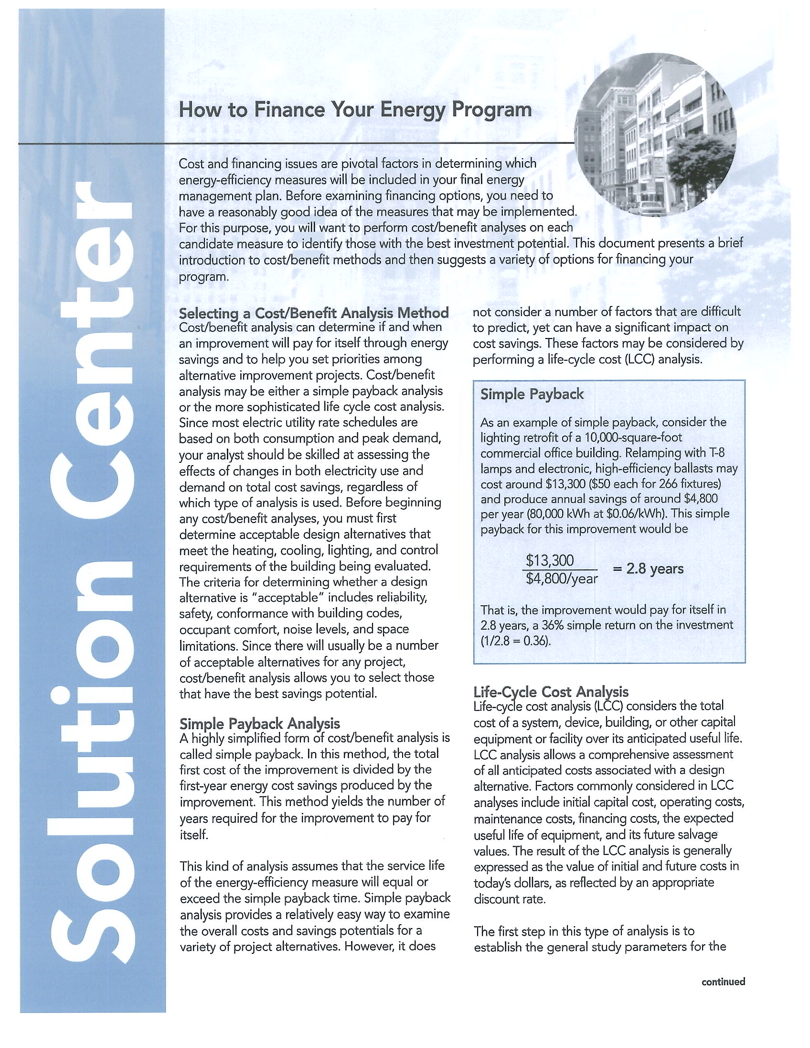
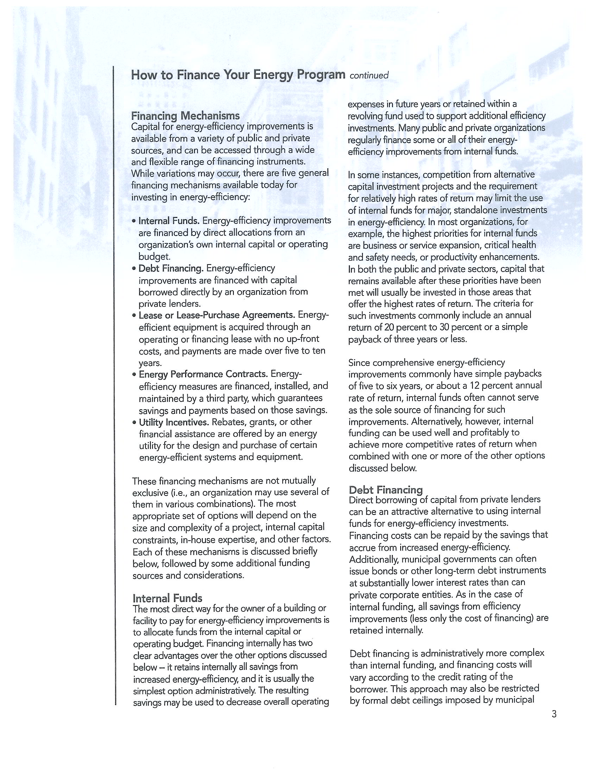
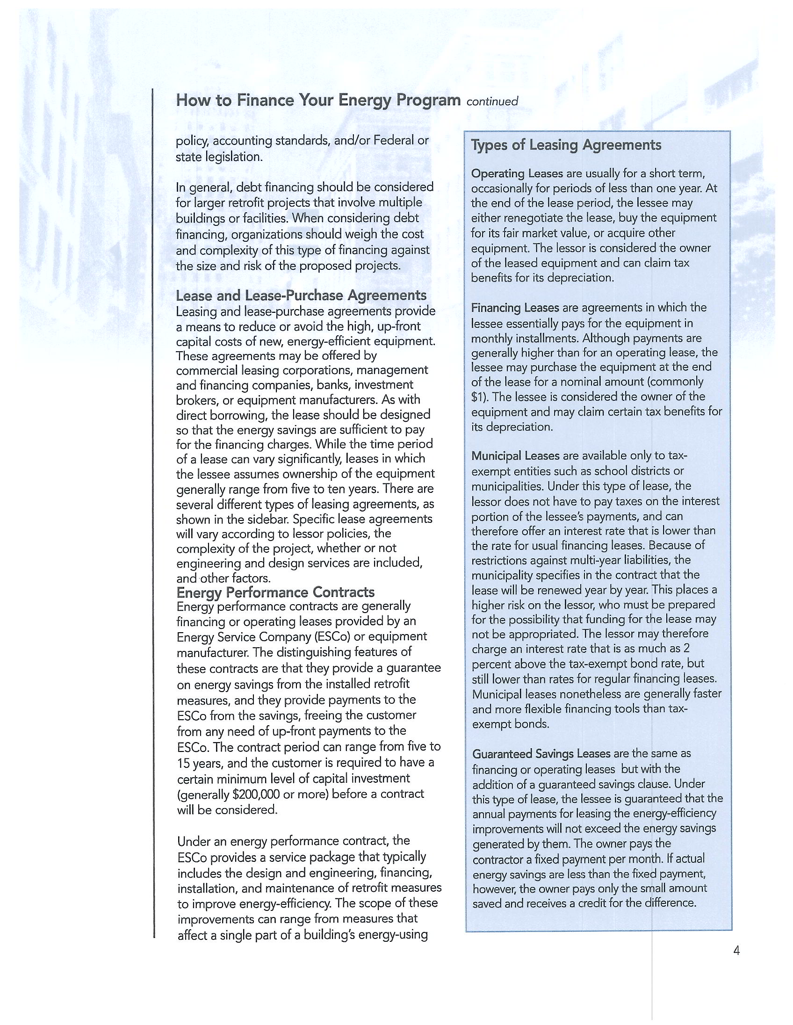
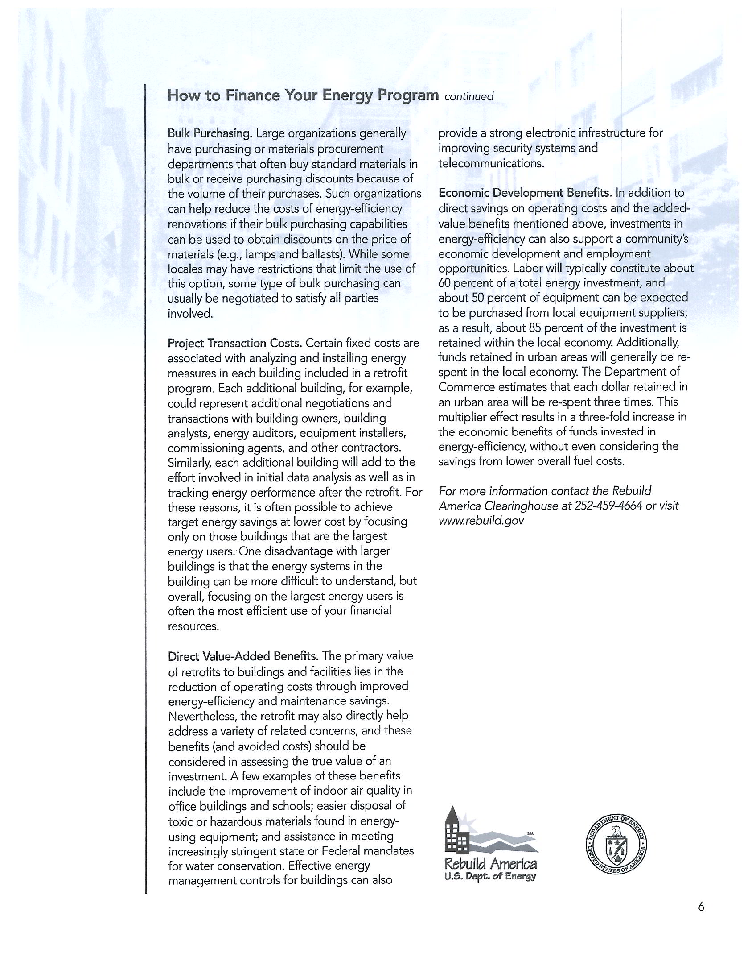

EXAMPLE OF AN ENERGY POLICY

California State University Dominguez Hills
Energy Conservation and Building Temperature Control Policy

The Federal Emergency Building temperature restrictions regulations, effective as of July 16, 1979, place restrictions on temperatures for heating, cooling and domestic hot water in commercial, industrial, government and other nonresidential buildings. The regulations generally require the thermostat be set no lower than 78 degrees Fahrenheit for cooling, no higher than 68 degrees Fahrenheit for heating and no higher than 115 degrees Fahrenheit for domestic hot water. The regulations also require room temperature set backs during periods when buildings are unoccupied. In response to these regulations and other continuing State and CSU mandates to conserve energy the following guidelines for building temperature control will be followed in all CSUDH buildings:

- People should expect temperatures, which are regularly between 68 degrees Fahrenheit and 78 degrees Fahrenheit and dress accordingly.
- Personnel working or teaching in rooms which are regularly colder than 68 degrees Fahrenheit, hotter than 78 degrees Fahrenheit, or who have chronic problems with drafts or stagnant air should report it, in writing, to Physical Plant. Physical Plant will attempt to adjust the air conditioning or make other modifications to correct the problem.
- No space heaters, whether state-owned or personal property, will be authorized for campus use unless a statement, approved by Physical Plant, is on file in the Physical Plant Office indicating that such equipment is necessary to maintain a temperature of 68 degrees Fahrenheit.
- In accordance with Department of Energy Regulations, heating and air conditioning systems must be turned off while buildings are unoccupied. This is normally between the hours of 10 p.m. and 7 a.m., Monday through Friday and all hours of Saturday, Sunday and holidays. Exceptions to these regulations should be requested, in writing, by the cognizant administrator and forwarded to the Director of Physical Plant.
- All windows in buildings that are air-conditioned will remain closed and as secure as possible to prevent loss of conditioned air.
- Use of refrigerators for non-instructional purposes should be consistent with good energy management practices. In order to discourage proliferation of personal refrigerators, approval for operation of such must be obtained from the Director of Physical Plant.
- Exemptions to this policy include, but are not limited to, maintaining laboratory plants or animal life; operation of data processing or other equipment which is temperature sensitive, storage of food or other perishables; and preservation of archives, books, art works or specimen. The cognizant administrator should send written request for exemptions to the Director of Physical Plant.
We realize that implementation of the attached building temperature control policy will change environmental and physical comfort conditions in many, if not all, of the buildings on campus. Physical Plant will respond as quickly as possible to adjust air conditioning and heating systems which are not providing temperatures within the 68 degree Fahrenheit to 78 degrees Fahrenheit restrictions mandated by the Federal Department of Energy Regulations. In most buildings heating, ventilation and air conditioning systems were not designed to accommodate these temperature restrictions. This is further complicated by numerous changes in building space and room usage over the years, making it almost impossible to maintain original design conditions. We hope all members of the campus community will cooperate as together we endeavor to achieve and maintain the goals of the Federal Building Temperatures Regulations.

* * * * *
Lighting Control Policy

- Artificial lighting is to be used only when natural light is insufficient to perform required function, or where the safety of the campus community is compromised.

- When artificial lighting is required, the following standard guidelines are to be followed:

  - Use the minimum amount of light required to perform the required tasks comfortably. The attached table indicates the desired level of illuminance [sic] that the University will attempt to provide. Physical Plant will consult with facility users in the adjustment of lighting levels.
  - Purely decorative lighting will be eliminated. Lighting for special events will be approved on an event-by-event basis.
  - Artificial lighting will be used only when areas are occupied. Whenever a room is unoccupied, the lights are to be switched off. This practice should be followed even if the room is unoccupied only for a few minutes.
  - When specifying new light fixtures and lamps, care will be taken to order the most energy efficient light source appropriate for the intended application.

It should be noted that energy efficient lighting should not detract from the esthetic value currently provided by lighting throughout the University. In most instances, it will be possible to provide more energy efficient lighting that also provides better quality illumination.

Recommendations for Illuminance [sic]

Type of Activity Lighting Levels Footcandles

Classrooms & General Offices 50 +/- 20%
Specialized Labs, Data Processing 75 +/- 20%
Drafting 100 +/- 20%
Work areas infrequently used (e.g., storage) 15 +/- 20%
Public Areas (e.g., hallways, etc.) 5 +/- 20%
Parking 1 +/- 20%

