Building 1

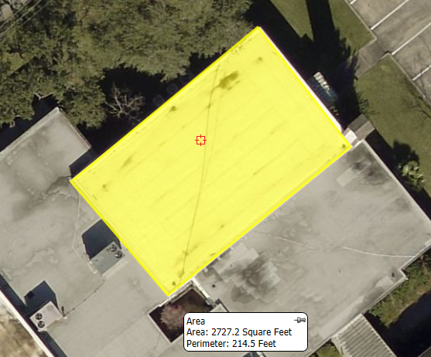
Diagram 1. Tapered roof system to efficiently move water to internal drains.
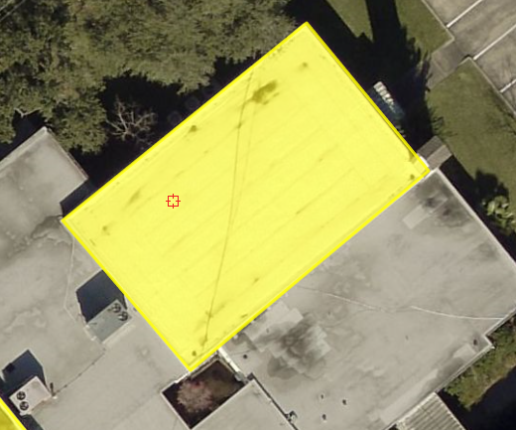

Building 2
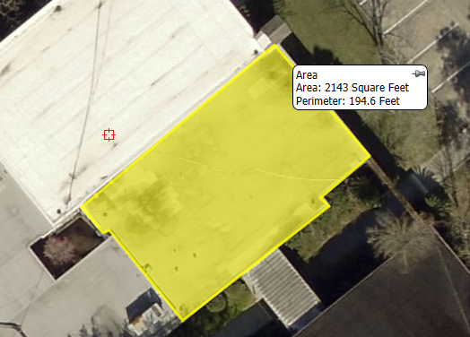
Diagram 2. Taper roof to flow to new gutter system and existing internal drains
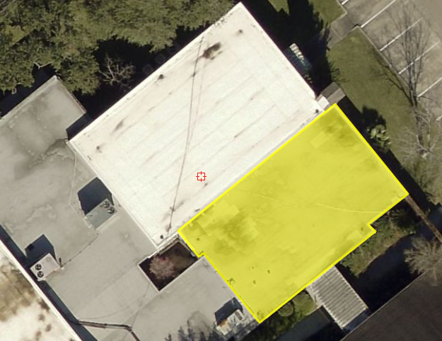

Building 3
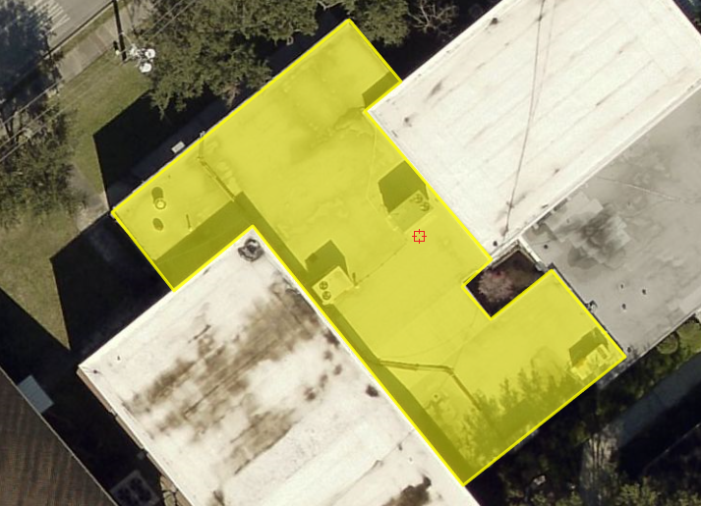
Diagram 3. Taper roof to flow water to new gutter system
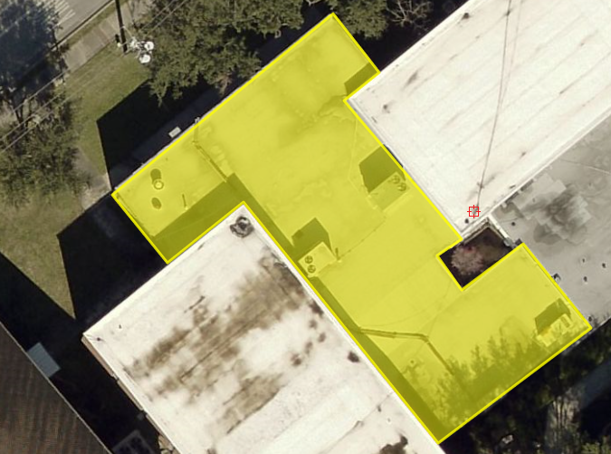
Building 4
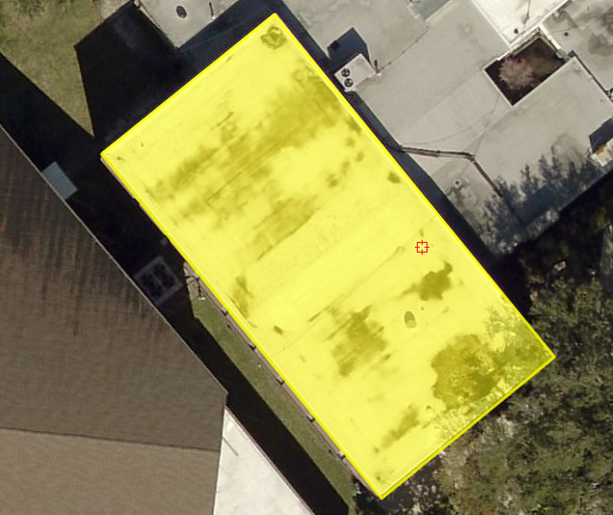
Diagram 4. Taper roof to flow water to existing internal drains

